Coach Learning and Reference Manual

For coach/facilitators
of
U9 through U12 players

Training and Game Day Guide

Contents Page
Welcome and Introduction Glen Buckley 3
Parent Meeting Agenda 5
Age Group Characteristics and Skill Priorities 6
How Do Children Learn 8
Guided Discovery 9
Practice Organization 12
Mosstons Slanty Line Theory 13
The Coaches Tool Box 14
Lesson Plans / Activities U9-U10 16
Lesson Plans / Activities U11-U12 23
Summary/ Contact 35
Glen Buckley Bio 36
Mission Statement and Association Information 37

Welcome and Introduction Glen Buckley
I was both honored and flattered to be asked to work with the Watertown Soccer Association and to put together these manuals. To be associated with such an innovative and forward thinking club whose primary focus is in the development of young athletes in the sport of Soccer, and life itself, was just too good an offer to refuse. Coaching young players and introducing them to the sport of Soccer can be a very frustrating yet extremely rewarding experience. Over the coming months I look forward to working with you to enhance the experience of both the players and coaches within the club.
It is my intention within these pages to minimize the frustrations and provide you with enough information to maximize the “Fun” for both the players and the coach. Understanding the players and their age characteristics, along with creating the correct age appropriate training and game environment is paramount in the development of both player and coach. Please think of yourself as a “facilitator” rather than coach. You will present the “game” to the children and challenge them to resolve the problems that the game presents. Children love to solve problems. We adults have a tendency to forget that and want to give them the answers. Telling them to shoot, boot it, go to it and hustle are all things that they are more than capable of working out for themselves! We just have to allow them the time to do so. Some will work things out quicker than others, we have to be patient, and they will get there in the end.
3rd and 4th Graders [U9,U10,]
5th and 6th Graders [U11, U12]
The activities contained in this manual are designed to encourage problem solving, communication, sharing information, collective reasoning, individual motor skills and small group work. You will also find some suggestions for a parent meeting and how to explain the philosophy of small sided activities and games. The main focus for the U9, U10 age groups is still their comfort with the ball, in Soccer terms dribbling. We should therefore be encouraging them to play with the ball and manipulate and master it. However, they will now have a better concept of small group cooperation and will work in 3’s and 4’s The U11 and U12 age groups are the ages of fundamental technical acquirement. This is the foundation phase of Soccer development. Players should be placed in activities that have lots of repetition in receiving and passing the ball.
The use of Guided Discovery as a teaching tool is explained and will help you in setting the correct environment and atmosphere during your sessions. Mosstons Slanty Line Theory helps you present the game to the children at a level they can all succeed. Thus addressing the age old question “Do I coach to the top third or bottom third of my group?”
The activities here are age appropriate and have a proven track record in player development. I encourage you to use them as a base for your practices, but you should also be creative and try some of your own ideas. Try a selection of activities from the sample plans to create your own session. If your team is not ready to move on then don’t……..repeat the session. The more players in an activity the more difficult it is for the players to have success. Decisions are harder and the space and time to make them is smaller and shorter. My general rule of thumb is to play 1v1, 2v2, 3v3 and 4v4 games. Running two or three 2v2 or 3v3 games side by side is better than an 8v8 or 9v9, where no one gets enough space or touches and so less chance to make decisions. The degree of difficulty can be changed by adding *neutral players or players on the outside of the activity [Bumpers on the outside or Targets on the ends] to set the players problems to solve without adding more players to the field of play. It is also important to note that the size of the area should be adjusted to suit the level of play. If the ball is constantly out of play, or is contested after every first touch then make the field bigger. If every second touch is a tackle or competition with an opponent then your player’s level of play requires more space to allow a second or third touch and even a shot or pass. As they get better make the area smaller. The Coaches Tool Box is a method in which to give information to the players during practice and games that is less intrusive. We are attempting to give the game back to the children. Practice it in conjunction with Guided Discovery and you will see a better flow to your sessions.
Remember at these ages children are not small adults and still have a hard time with Soccer as a team game. Keep your expectations and goals realistic but challenging. These age groups are very important in all sports not just soccer. In a survey conducted with 11 to 14 year olds that had dropped out of playing soccer, the number one reason for dropping out was it is not FUN, the second was the coach and third was the parent. So given the demographics of Soccer in the USA that really means the volunteer/parent coach was not creating a FUN environment for the players! Kids love to play, so let them……remember The Three L’s….No Lines, Laps or Lectures……and play small sided games in practice.
Please enjoy your time as a coach if you work at it, it really can be a very rewarding experience, just don’t take yourself too seriously and smile……your players will appreciate it.
*Neutral Players. A neutral player is a plus player that plays for the team in possession. i.e 3v3 plus 1, the one being the neutral player.

Sample Parent Meeting Agenda . Have the schedule of all practices and games and the weather/medical emergency plan attached to these agendas. Adapt the following to suit the age and competitive level of your group.

Team Goals: Our primary goals as a team are to have fun and to develop as young soccer players. I hope to be able to teach the players needed skills that will help them improve in the game. We will have fun practices that focus on technical skills. Winning will not be a priority for our team. Team priorities will be developing skills and enjoying the game. If you watch practice you may at times see us engaging in activities that do not look like “real soccer”. Please be assured that all activities we do will help with skill building, motor development, and enjoyment.

Style of Play: I will be encouraging the players to try new things and to be creative. We will focus primarily on developing dribbling skills, and also spend time on passing, receiving, and shooting skills so players begin to develop in age appropriate skills. It is my hope that players have the confidence to show their skills in the game and improve their comfort in possession of the ball. We will try to move up and down the field as a team and I may, on occasion, move players into different positions to help them learn all parts of the game. We will spend most of our time on skill development.

Attendance: I will be at every practice and game, foregoing any unforeseen emergencies. Please make every attempt to have your child at every practice and game (on time) as it is part of learning the responsibility of being on a team. Given our hectic lives, I do understand that players may have conflicts here and there. Please let me know before the first game of any conflicts you might have for the season so I can prepare my practices accordingly and we can make sure our team has enough players at every game. Please have your children at the field ???? minutes before the game starts and please pick up your children promptly after every practice and game.

Discipline: I have been told that I run a tight ship and will continue to do so. If players are acting out, I will ask them two times to fix their behavior. If they fail to do so after these warnings, I will sit them down at practice or during a game. If the behavior continues, we will need to talk about it to find a way to help resolve the behavior best without it detracting from the rest of the players’ experiences on the team.

Communication: I am typically a difficult person to reach by phone. The best way to contact me is via email at soccercoach@sampleclub.com. Should you wish to talk by phone, my office number is 1-800-852-6666 and the best time to reach me is between 12pm and 3pm. If these times do not work, let’s schedule a time that works for both of us. Please do not ask to talk to me during a practice or game or immediately before or after the game or in front of your child. I do encourage open communication and questions as we all hope to make this a great experience for the children.

Sideline Behavior: Please be supportive and enthusiastic on the sideline during games. The players and I will truly appreciate your applause and encouragement. However, if everyone is coaching, this will only confuse the players. Please do not coach from the sideline. The players need to make their own decisions and we need to support them and educate them at practice. Remember, you are a role model on the sideline for the players. Please set a good example.

Overall: I am excited for a great season and I hope you and your child are as well. Let’s all have fun and enjoy the game. If you have any questions, please, let’s keep open communication.

Player Characteristics 3rd and 4th Graders U9 and U10

- Attention span lengthens from U8 and they start to show the ability to sequence thought and actions
- They start to think ahead and think “If this, then that”
- They are more inclined towards wanting to play soccer rather than being told to play
- Demonstrate increased self-responsibility – bringing a ball, water and all gear should now be their complete responsibility
- They start to recognize fundamental tactical concepts
- Children at this age begin to become aware of peer pressure
- Players greatly affiliate with their team or their coach—“I play for the Tigers” or “I play for coach Amy’s team”
- Players at this age are extremely rule bound—remember each rule you create is the equivalent of a bar in the prison in which you would like to live
- There is a wide continuum of maturity evident on most teams
- This is a crucial age for technical development through repetition

Age Group Skill Priorities

U9 U10 Field Players
Continue with dribbling focus from U8
Passing with inside and outside of both feet
Shooting with both feet
Receiving the ball with all parts of body
Proper 1 vs 1 and 2 vs 1 defending and attacking
Intro to 2 vs 2

Goalkeepers
Basic catches and throwing techniques
Diving to both sides

Player Characteristics 5th and 6th Graders U11 and U12

- All children are maturing at different rates and are sensitive to that fact.
- Players need to warm-up and stretch as muscle pulls and other nagging injuries are common otherwise.
- Players will typically understand elemental abstract concepts and hypothetical situations.
- They like to solve problems.
- Peer evaluation is a constant.
- Egos are sensitive.
- Coordination may depend on whether or not they are in a growth spurt.
- Technique still needs to be reinforced constantly.
- Playing too much can lead to overuse injuries.
- Playing too much and not feeling like they have a choice in the matter can lead to burnout and drop-out.
- This is the dawn of tactics!
- Keep asking the players to be creative and to take risks, we never want them to stop doing these things and they will enjoy the freedom of being creative.
- Ask for feedback from them, they will tell you how things are going.
- Try to hand over leadership and ownership of the team to them. They will enjoy leading and it will add to the learning environment.

Age Group Skill Priorities

U11 U12
Field Players Goalkeepers
Continue with all U-10 priorities Proper positioning
Basic combination play Breakaway and tipping high balls
Proper 2v2 defending and attacking Punting and goal kicks
Increased technical speed of play
Ability to chip the ball
Accurately play long passes
Basic understanding of roles of 3rd defender and attacker

How Do Children Learn?

Children learn by knowledge of results.
Not the winning and losing, or by points gained type of results, but the result of doing. If a child tries something and is successful, they are more likely to want to do it again. Repetition is the key. Practice Makes Perfect is a phrase we have all heard and used. However caution should be taken as practicing the wrong thing may make you perfectly bad at it! Maybe we should change the phrase to Practice Makes Permanent. The point being that the correct environment and correct practice is essential to learning.

Learning.

It is critical for us to recognize children have varied learning styles. Some children learn optimally when they hear things described to them. Others learn best when they see things. However, other children learn best by doing. Depending on the source, estimates claim 20-30% of children may retain information they hear and, possibly, up to 45% of children retain what they see. This is compared to 80% retention of what they do. Here are brief descriptions of the varied learning styles of children:

Auditory Learners

Auditory learners learn best by listening. They often understand the nuances of speech we convey through tone, speed, or pitch. You might see these children reading aloud in school as they learn best by hearing. On the field they will listen intently to your words. It is important you provide clear, concise, and direct instructions.

Visual Learners

Visual learners learn best by seeing. They will benefit most not from your description of activities, but rather by seeing a demonstration. The adage “a picture is worth a thousand words” is often very true to visual learners. In school, these children prefer diagrams and overheads. On the field, they prefer to see what they need to do.

Kinesthetic Learners

Kinesthetic learners learn best by doing. The large majority of your players will excel through this means of learning. Children in kindergarten and early elementary school are especially likely to learn this way on the soccer field as it is the primary method of learning in life for them. They learn through exploration and touching. You may actually find some children who are easily distracted unless completely engaged.

Overall, we need to make sure all of our players understand the messages we are trying to provide. The important thing to note is the large majority of players will understand most easily by doing. Therefore, we need to make sure they are active as much as possible. Giving brief directions, providing a clear and simple demonstration, and then having the players engage in the activity will prove the optimal method of teaching. By doing this, we quickly cover all types of learning. However, if your description is too long, you will find you have lost some children before you even start. A brief description is key. Once you get the children playing, you can give personal attention to players who do not understand while the remainder of the players are actively engaged in the activity.

Guided Discovery

If you listen to the words shouted from the sideline of a typical field, you are likely to hear many specific directions from coaches and spectators alike. Every time a child receives the ball, they are likely to hear at least 3 or 4 people telling them what to do. We then see children kick the ball forward as hard as they can or run with it as fast as they can seemingly without any thought. They do not do this because it seems like the best choice. In fact, it is unlikely those players even ask themselves what the best choice of action is in that situation. Often, they are simply doing what they are told to do by the shouting coach or spectator.

If we asked these players to explain their decisions to us at the end of the game, or even immediately after their actions, it is unlikely they would be able to provide us with a rational explanation as to why their actions were warranted. If these players are placed in the same situation at a later time, they will not have a thoughtful knowledge base from which to draw upon when trying to solve the situation. It could be that they make the same mistake when placed in the same situation. Otherwise, they could simply choose a different response randomly in hopes they will eventually find something that works. By the time this trial-and-error method of solution proves fruitful, it is likely the player will be so frustrated they do not want to play anymore.

So what can we do as coaches to prevent players from making the same mistakes and feeling growing frustration? We could continue to yell louder and hope they listen to us constantly when playing. Of course, then it does not really seem like they are playing. Rather, it seems we are puppeteers using our players as puppets. Our challenge then is to help provide the players with the tools to make these decisions for themselves while on the field. If our players understand when it is best to kick the ball forward or to run forward with the ball and why they are making all the decisions they are making during a game, then they will be able to improve their own play (even during the game) and be rewarded with success. Further, if they become thoughtful, strategic players, they will have more fun, gain confidence, and your team’s performance is likely to improve continually.

By asking our players questions to which they must come up with answers, we can insure that our players are thinking, as opposed to mindlessly following our directions. Of course, if we do not ask guided questions, we may find ourselves and our team roaming aimlessly amidst philosophical clouds. By asking guided questions, we can help maintain focus and direction for our team and help provide learning experiences for our players.

When referring to guided questions, we mean our questions should place our players on the right track (guide) in order be able to solve the questions we pose. Some questions may be quite direct and simplistic such as:

- What part of the foot do you use to make a short pass?
- Where should you aim when shooting on goal?

Questions such as these are called “low order” questions as they demand factual, memorized answers. In contrast, we could ask “high order” questions that challenge our players a bit differently by asking them to weigh options within the framework of a larger process. High order questions beg interpretation and comprehension over memorization or recall. Examples of “high order” questions include:

- How can you get the ball down the field quickly?
- How can you protect your ball?

Utilizing questions such as these will help our players learn and retain information that will aid them in making optimal choices as they play. It is not better to ask “high order” or “low order” questions, as they both serve helpful roles in learning. Our task as coaches is to find the proper balance of “high order” vs. “low order” questions for each of our players. In consequence, rather than waiting for us coaches to fix errors of play at half-time, our players will likely look to solve errors immediately during the game as they have been trained to do so in practice.

As mentioned earlier, an enormous benefit of asking questions such as these may be how players develop confidence and learn to trust their own decisions. Of course, we must temper the difficulty of our questions to insure they achieve the success necessary to help build their confidence. In fact, players may be a bit uneasy when asked these types of questions (especially high order) at first. For this reason it is a good idea to provide a few positive words before asking a question. For example:

- Great….so how could we do it faster?
- I like that answer…what other skill can we use to get the ball to our teammates?
- Now you’re getting the idea! Where could you position yourself so that you could see both the player you are defending as well as the ball?

Now armed with the confidence and skill to evaluate situations and make decisions on their own, these players will look within themselves (not toward the sideline) in order to determine what choice to make on the field. As they become skilled at answering these questions, they will be able to increase their quality and speed of play. This will allow us to sit back in our chairs during games and appreciate the fruits of our practice efforts.

Using this method of coaching, we can help develop more competent players and more confident people. Although coaches and parents alike may find their sideline shouting ignored as players gain competence, I think both groups would be happy with that result. Here are a few more examples of guided questions we hope you will try to incorporate into your coaching:

- In a 3v3 situation, what’s the best way to get the ball to your teammate? Let’s try it!
- What happens when you pass the ball behind your teammate? Let’s try it!
- Now, if you want to make sure your teammate goes forward, where do you want the pass to go?
- Why didn’t that pass work? So, how should we do it this time?
- How can we get the ball to the other side of the field?
- Why is it important for you to lift your head up when you have the ball?

Practice Organization

Coaches should organize their practice session in a progressive manner, easy to difficult or simple to complex. It must provide for individual, small group, large group and/or team activities. An example of a practice format would be:

A. Warm-Up – the warm-up prepares the player both physically and mentally for what is to follow in the training session. Warm-ups should incorporate a technical and/or tactical element as a lead in the training session. Stretching should be integrated throughout the warm-up.

B. Small Sided Activity – small group games that provide a lead into larger group games or activities. Small group activities will provide the majority of work within your coaching session and should cover your one chosen topic (not many different topics). This activity may be non-directional or directional and will continue providing the technical repetitions introduced during the warm up.

C. Expanded Small Sided Activity - small sided games that now include more players and closely resemble the game of soccer. This activity must be directional and include a goal (can be multiple goals, end-lines or target players). Your topic still needs to be focused and taught during this activity.

D. Free Game – this does not necessarily mean 11v11. It means a game (without any manipulations) including as many players as you can up to the number that play in your league games. A U12 team playing with 8-a-side in their league matches should try to end with an 8v8 scrimmage. Similarly a U14 team playing 11-a-side should end with an 11v11 game if possible.

E. Cool Down – following the training session a cool down of light, low intensity exercise and static stretching aids the player to recover from the training session. They have worked hard and this will help them to unwind physically and mentally. Could use co-ordination activities as a cool down

Mosstons Slanty Line Theory

As mentioned previously you will find a great range of abilities amongst the players on your team. Because children are maturing at various rates, our most challenging task may be to find a way to run a practice in which we challenge each player at a level that befits their abilities. Do you set goals for all your players that are based on the performance of your best player? If so, do your lesser players have any chance of actually attaining these goals or are they constantly faced with failure? In contrast, do you set your goals according to the abilities of your lesser players in order that everyone on your team can reach the goals? If you do this it is likely your better players will find practice extremely boring and they will not develop or have fun. We are stuck with a problem if we do either of these things, so what do we do?

STRAIGHT LINE SLANTY LINE

Think of practice as a jumping contest. If we hold a stick parallel to the ground and eight feet in the air (see picture above) and then ask all players to jump as high as they can and touch the stick with their hand, we will find most players have no chance of success. However, if we hold this stick at a slant and challenge players to touch the highest part of the stick they can reach, then each player can experience some success. Each time they jump, we can challenge them to try to improve the height they reach on that slanted stick. Therefore, they experience success and have reachable goals to strive for going forward. This is Mosstons Slanty Line Theory in practice. By challenging each player in a manner that befits their abilities we will keep every player engaged in the task and cognizant of challenging, yet reachable goals. By doing this, we are much more likely to aid in every player’s development than if we challenged all players at a standard that only benefit a few of the players. Remember, children tell us a primary component of fun is seeing themselves improve at a task. Allowing each player to see themselves reaching new goals will clearly enhance their enjoyment!

The Coaches Toolbox

During a session, a coach must recognize a “coachable moment” to give information to their players. A coachable moment is when a technical or tactical issue arises, based on the topic for the session. Each activity in a session plan will create a “coachable moment”. As coaches, we watch for these instances so that we can make our coaching points and teach our topics. With practice, coaches will learn how to find these coachable moments and recognize them in their sessions.

Once a coachable moment is recognized, there are several methods coaches use to give information to the players. These methods are called “the coaches toolbox” and are listed from the least to most intrusive. These methods are explained below:

Coaching Methodology

- Allow the conditions of the game to coach the topic
- Use touch restrictions (one touch, two touches, mandatory two touches)
- Adjusting the size of field
- Adjusting the size of goals
- Use a neutral player to provide a numbers up opportunity
- Let your players play the game
- Coach in the natural stoppages of the activity- ball goes out of play
- Wait for the ball to go out of play, then recreate the coachable moment
- Natural stoppages are throw-ins, goal- kicks, restarts from fouls…..
- Coach in the flow of the activity (large group)
- Direct information to groups of players, “push forward!”, “slide left!”….
- Information must be concise and clear to all of the players you are speaking to
- This is instruction, not a running dialogue with your team
- Coach individual players as the activity continues
- Talk to one player either from a distance or close
- Clear, concise information must be provided
- Have a player step out of the activity and you then provide them with short instructions
- Coach using the “freeze” method
- Stop play when the “coachable moment” occurs
- Players must stay exactly where they were when the “freeze was called”- if not, the picture of what is being taught changes completely
- Review what happened, rehearse what they could have done to find success, and restart play from a point prior to the point of your stoppage.

Regardless of the chosen method, remember to keep instructions short, detailed and topical (30 seconds for your coaching point). Paint a clear picture of what you want your players to do by reviewing what occurred during the run of play, rehearse the situation so your players gain success with what you are teaching them and then restart play using what you rehearsed with your players.

As we coach, we need to allow our players to play the game. Making a maximum of four coaching points per activity, using any of the methods discussed above, will help keep your activity flowing yet still provide instruction to your players. We do not need to coach every mistake that occurs as we would be stopping play too often. Pick your times to make your points and teach your players!

Lesson Plans and Activities 3rd and 4th Graders U9, U10

1) Technical Box (Warm up)—Everyone with a ball, use inside, outside, and sole of foot. Have players dribble with speed (outside of foot), change direction, and perform moves. Coach calls out moves or changed in direction and sets the pace as the manipulator of the session. Version 2: As players get comfortable, coach can walk around and put pressure on players as they are performing dribbling tasks. This adds fun and interaction. Version 3: Make the game a knockout game in which players try to knock each other’s balls out of the grid while maintaining possession of their own. Note: You may wish to have them perform a skills task before re-entering such as 10 toe touches or juggling 5 times. You do not want players sitting out. (15 minutes)

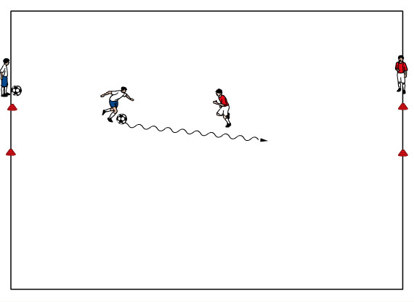
2) 1v1 to Goals (Small Sided Activity)
In a 15x10 yard grid, players line up on opposite sides. The first player in each line alternates attacking the player opposite them. When the attacker dribbles through the goal they are awarded a point. If the defender wins the ball he or she can counter attack to the opposite goal to also score a point. The players switch to the opposite line if a goal is scored or the ball goes out of bounds. The coach rotates the lines so all players get to compete against each other.
(15 minutes)

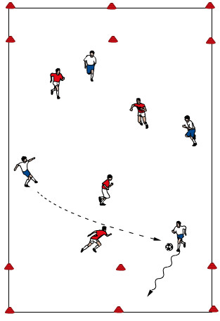
3) 2v2, 3v3, 4v4 End zone Game (Expanded Small Sided Activity)
Teams comprised of 4-6 players depending on numbers and space. To score you must dribble into the opponent’s end zone while under control (created with discs). Passing in will not count. Stress recognizing opportunities and bursting into space while under control of ball. Version 2: force players to be comfortable on the ball by taking a minimum of 3/4 touches every time they get the ball. (15 minutes)

4) 6v6 scrimmage (Game)---Depending upon numbers, space will change. Ideally, finish with the number you normally play with in games. Play a regular game with goalkeepers. Perhaps stop the game 1-2 times to highlight good passing technique and decision making of when, where and how to pass. (25-30 minutes)

PASSING
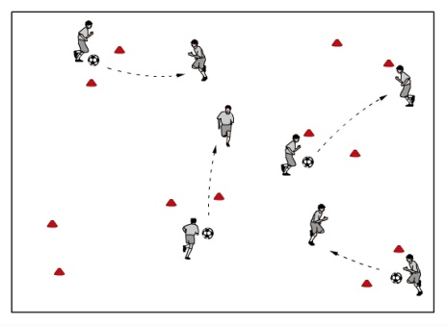
1) Gates Passing (Warm up)---Randomly place many pairs of cones making small goals (1 yard wide) in a large space (30 x 20 yards). Players are paired up and must successfully pass the ball through the cones to their teammate to earn a point. Again, players try to accumulate as many points as possible in the time allotted. Have them pass only with their left foot or right foot, or the outside of their foot. (15 minutes)

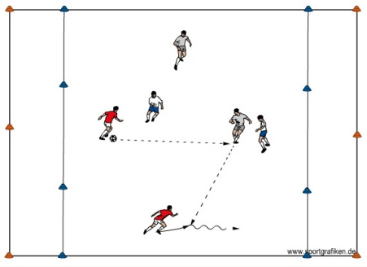
2) 2v2 +1 or 2 Neutrals to end zones
Players combine to get a player into the end zone in complete control of the ball. Players can dribble or run the ball in for a point. Passing a ball into the end zone to a player arriving [making a run] at the same time as the ball to receive it and control in the end zone scores two points.

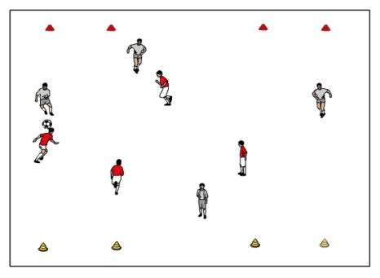
3) 4 vs 4 To Four Small Goals (Expanded Small Sided Activity)---In a 35 X 30 yard grid with a small goal in each corner teams attack the two opposite goals and defend their two goals. The coach will set up as many grids as needed to accommodate the players. When the ball goes out of bounds it can be passed or dribbled in to play. The teams should be rotated every three minutes until all groups have played against each other. (15-20 minutes)

4) 6v6 scrimmage (Game)---Depending upon numbers, space will change. Ideally, finish with the number you normally play with in games. Play a regular game with goalkeepers. Perhaps stop the game 1-2 times to highlight good passing technique and decision making of when, where and how to pass. (25-30 minutes)

Coaches should build their own lesson plans from the following lists of activities. Choose 1 from each category. You may also use any activity from the U5/U6 listings. Just adapt to suit the level of your players.
The activities are listed as:

Warm Up
Small Sided Activities
Expanded Activities.

Each practice session should end with a scrimmage with no restrictions and include Goalkeepers.
6v6,7v7 or 8v8 should be played. However, it is also ok to play two side by side 4v4 games to give the players more touches.

Warm Up Activities

- Shield-Steal---Half of players in the group have a ball and half do not. If you do not have a ball you need to steal one from someone who does. If ball goes out of bounds, person who touched it last does not get possession. You can teach players the technical points of shielding as a group at start of activity. Show technique with body sideways, arm providing protection, ball on outside foot, knees bent, turning as defender attacks, using feel to understand where defender is going. Fix technical shielding errors throughout this activity and make sure entire group knows how to properly shield.

- Ball Tag---In a space about 40yd X 30yd give every player a ball and put people in pairs. One person is being chased while other does the chasing. Once the chaser hits the ball of the chasse with their ball, the roles reverse. Version 2: make two teams to make more dynamic and see which team has the least chasers at the end (winners).

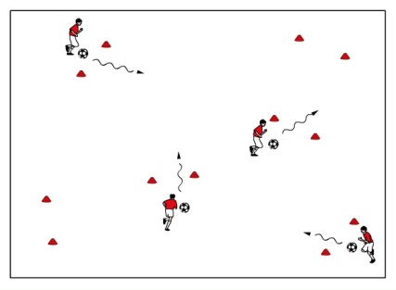
- Gate Dribbling---Randomly place many pairs of cones making small goals (1 yard) in a large space (30 x 20 yards) and have players dribble their balls through the goals for a point. Players try to accumulate as many points as possible. Have players count up their total points in the time you provide them. After doing once, ask them to improve their score by 2 and play the game again. Challenge each child individually. Version 2: Players can only dribble through goals with their right foot or their left foot. Note: You may need to make a rule disallowing players from dribbling back and forth in one goal or just two goals.

- Numbered Passing---Number the players on your team and have them move around and pass the ball to each other in sequential order. Make sure the ball never stops, players never stop moving, and the ball never leaves the grid you have set. Try to add balls to add challenge to the activity. Stress proper passing technique as well as having receiver’s show for the ball and communicate. Version 2: You may tell players to pass with a certain foot or a certain part of their foot as the activity continues. Version 3: As players get comfortable, you can limit their touches to 2 touches.

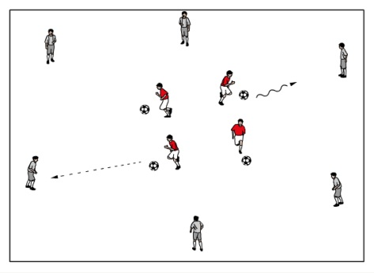
5) Dutch Circle---Half of the players create a 25-35 yd outer circle and have soccer balls at their feet. These players must always be alert and on their toes. The other half of the players are in the middle of this circle and do not have soccer balls. The inner players check to players on the outside to receive a pass from them. They receive the pass and then play to any player on the outer circle who does not have a ball (except player who passed to them). They then check to another person on the outside that has a ball and repeat this process for about 2-3 minutes until coach switches players on outside and inside. Focus on both front foot and back foot receptions and add in feints (i.e. ball runs through legs, ball runs across body, or take ball early). Work on receiving with both feet and receiving sideways-on.

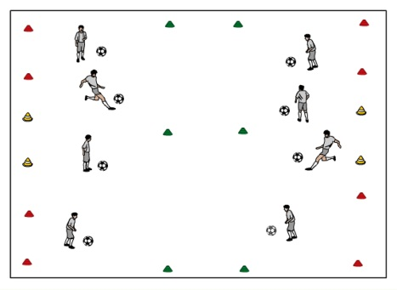
- Clean Your Backyard---Break group into two teams and have each team stay only on their half of the field. Place a 6 yard buffer zone between halves that no one can enter or cross. Each player needs a ball. Place three small (2-3yd) goals at the far end of each side of the field. Have both teams shoot balls at other team’s goals in an attempt to score through anyone of the small goals (below knee height). Players cannot cross the buffer zone or go into the other half. Balls get recycled naturally in the game. This is a competition and teams need to keep score. Play 2 or 3 games and have teams re-strategize between each game. Teams can play defense though no hands. Only shots with laces count as goals

U9, U10 SMALL SIDED ACTIVITIES:

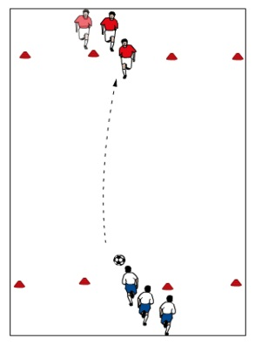
- 1 vs. 1 To lines---In a grid 10x10 yards, players line up on opposite sides. The first player in each line alternates attacking the player opposite them. When the attacker dribbles over the line they score a goal. If the defender wins the ball he or she can counter attack to the opposite line to also score a goal. The players switch to the opposite line if a goal is scored or the ball goes out of bounds. The coach rotates the lines so all players get to compete against each other. *2v2 to lines in a grid 15x15yards

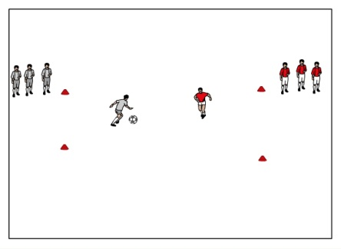
- 1 vs. 1 To Two Small Goals---Same grids as above except now there is a three foot goal in the middle of each line. Attackers try to score by passing the ball through the goal. Defenders can counter attack to the opposite goal if they win the ball. Players switch sides after a goal or the ball goes out of bounds. The coach rotates the lines so all players get to compete against each other.
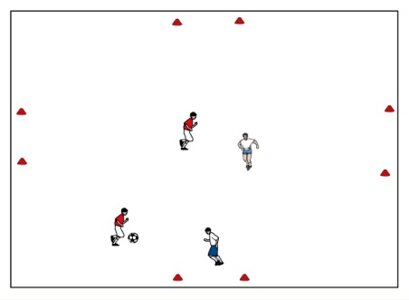

- 2 vs. 2 to Four Cross Goals---Teams defend one goal and have the opportunity to score on the other three, you must dribble through a goal to score a point. The goals are on the ends of a large cross in a square grid roughly 10yd X 10yd. Have one team of 2 on deck, they come on when a team gets scored on twice. Game is continuous, they must run on immediately.

- 2 vs. 2 To Four Small Goals---In a 15 X 15 yard grid with a small goal in each corner teams of two attack the two opposite goals and defend their two goals. The coach will set up as many grids as needed to accommodate the players. When the ball goes out of bounds it can be passed or dribbled in to play. The teams should be rotated every 3 minutes until all groups have played against each other.

- 2v1+1 to goal---In a 12x17 yard grid add two 3 yard goals on each 12-yard side. The attacking team looks to combine (over-lap, take-over or wall pass) or attack on the dribble or shoot (knee height or below). The defending team must have one player in the goal and one on the field. The goalkeeper must stay in the goal until the attacking team loses the ball, then the player that was in the goal can come out to attack (while the team that just lost possession must send one player back to play in goal)

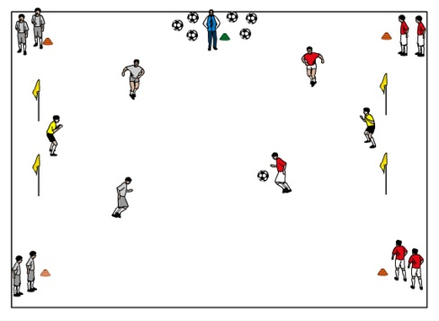
- 4-Corner Shooting---On a field 20 yards wide x 25 yards long, position two goals at each end. Split group into two teams (red and blue). Position half of the red team in a line behind one corner of the field and the other half of the red team in a line behind the other corner of the field, at the same end. Organize the blue team in the same manner at the other end of the field. Select a goalkeeper for each goal and rotate that player every 5 minutes. The coach is positioned at the midfield line, outside the field, with all the soccer balls. When the coach kicks a ball into the field, the first person in each of the four (4) corner lines enters the field to play. The game becomes a 2v2 + keepers activity. Play continues until the ball goes out of play or a goal is scored. When this happens, the players on the field quickly get back into their original lines, keepers stay on, and the coach kicks the next ball in for the next 4 players. The coach should serve the ball toward one of the corner lines (risk/safety management). When all the balls have been served, the players can retrieve them and dribble them back to the coach for another round of games.

U9, U10 EXPANDED SMALL SIDED ACTIVITIES:

- 3 vs. 3 To Four Small Goals---In a 20 X 25 yard grid with small goals in each corner. Teams of three attack two goals and defend two goals. The goals are set up along the 25 yard lines for extra width in the attack.

- 4 vs. 4 End Zone Game---Teams comprised of 4-6 players depending on numbers and space. To score you must pass the ball to a teammate into the opponent’s end zone (created with discs). The player cannot go into the endzone until after the ball has been passed. Stress recognizing opportunities and timing of passes.

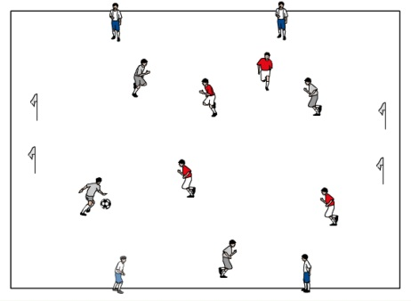
- Bread and Butter---Typical 4 vs. 4 but with an additional 4 players who stand on outside of field and can be used by either team as outlets (can limit the touches of these players if they have the ability (ie: two touches). If a team gets scored upon, they become the team on the outside and the outside team plays on the field. Use approximately a 20x25 yd area. May restrict the players to 2/3 touch to force quicker decisions, and better body position before the ball arrives. Keep score and make the game competitive.

- 4 vs 4 + 4 on deck---Two teams playing to one goal each. First team to two goals stays or if two minutes pass by, the longest team on gets off and new team comes on. Captains on each team keep score.

General coaching points:
- Stress proper technique in all your activities
- Be concise and direct with your comments
- Recognize that players will tune you out if you speak for longer than roughly 25 seconds
- Keep practice active so players will not drift
- Remember that players are watching your facial and body reactions, be aware and be sensitive
- Let kids be kids and do not be afraid to show your fun, childlike sense of humor
- Keep things fun and challenging and your players will both smile and develop!

Lesson Plans and Activities 5th and 6th Graders, U11, U12

Objective/Purpose: Possession is the ability to keep the ball individually and collectively in small groups and as a team. The technical aspects of passing and receiving and the tactical aspects of movement and shape are key to our player’s success. The possession play of younger players tends to be slow, thus the numbers must be small so that the players can achieve success through multiple repetitions in a less cluttered playing environment. As players get older, play speeds up and they can handle activities with larger numbers.

Coaching Points:
- Proper receiving technique: good body balance, eyes on ball, body in-line with the path of the ball, movement to ball, appropriate touch on ball (cushion or propel)
- Proper passing technique: good body balance, placement of non-kicking foot, foot surface, ball surface, eyes on ball when striking, appropriate pace (weight)
- Surveying the area, intelligent movement, looking for target early, anticipation, keeping good body shape, head up, preparing to receive the ball, preparing to pass the ball
- Reinforce the roles & responsibilities of the 1st attacker (ball), 2nd attacker (support) and 3rd attacker (length or width) within the game. Especially, their responsibilities in keeping possession for their team (combination play) and penetrating into dangerous space behind the defense

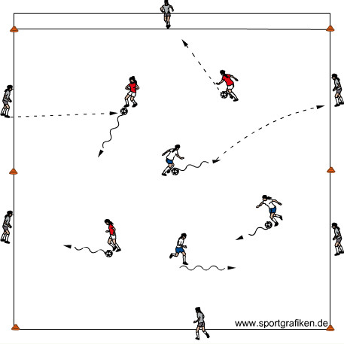
1) Inside-Outside - - One soccer ball per two players. Separate players into two groups. One group of players, without soccer balls, forms a 30 yd x 30 yd grid. These players are the outside players (Outsiders). The other group of players, equipped with balls at their feet, position themselves inside the circle. The players inside the circle (Insiders) dribble about the grid freely looking for an opportunity to pass the ball to a player on the perimeter of the circle (Outsiders). The Outsiders must one or two touch the ball back to the Insider. The Insider then controls the ball and looks for another Outsider to pass to. After approximately two minutes, the Insiders become Outsiders and vice versa. Variation: The Outsiders start with the ball in their hands. The Insiders move around freely inside the circle without a ball. The Insiders call for a ball from one of the Outsiders. The Outsider serves a ball (on the ground or in the air) to the Insider, who must one or two touch the ball back to the Outsider (server). (15minutes)
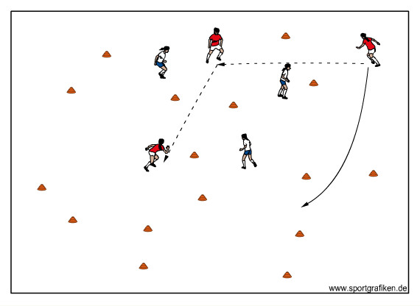
2) 3v3 or 4v4 Gate Game - - One ball. In an open area set up 6-8 gates (2 cones about 3 yards apart) at many different angles all over the field space. Organize players into 2 teams. Play keep-away in the field space. Points are awarded each time a team can pass the ball through any gate to a teammate and keep possession. The game is continuous constantly looking for another gate to attack. When the defending team wins possession of the ball they are on the attack. Play games to 5 points or for a certain time period (i.e. 5-10 minutes). Variation 1: Add more players to each team. As you add more players to the group, increase the playing space, add more gates and position the gates farther apart. (20 minutes)

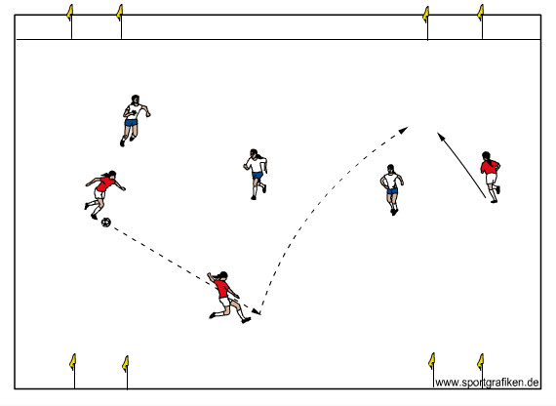
4) 3v3 or 4v4 To Four Small Goals - - In a grid 30yds x 35yds with small goals near each corner. Teams of three or four attack two goals and defend two goals. The goals are set up along the 35yd lines for extra width in the attack. Each team attacks the two goals opposite them and defends the two goals behind them. The goals are three feet wide and are placed near each corner. With three players, the attacking team should create a triangular shape. With four players, the attacking team should create a rectangular (diamond) shape. (20 minutes)

5) 5v5/ 6v6 Game or 8v8 game) - Play the larger game to two goals with Gk’s. Encourage your goalkeeper to communicate to the team regarding keeping possession for the team. Emphasize the coaching considerations made throughout the training session. Stay on topic. (25 minute)

6) Cool Down– Controlled juggling (thigh-thigh-foot-foot). Statically stretch the large muscle groups. (10 minutes)

U11 U12
Objectives: To help players recognize when to penetrate by dribbling, passing and/or shooting.

Coaching Points:
- Reinforce dribbling technique – all parts of foot / keep ball close / on toes / push vs. kick
- Reinforce passing technique – inside of the foot - ankle locked / toe up-heel down / hit middle part of inside of foot / follow through-land on kicking foot / plant foot next to ball and facing where you want the ball to go // outside of the foot – ankle locked / front part on the outside part of foot (not toe and not middle of outside)
- Reinforce shooting technique – ankle of shooting foot locked with toe pointed down (instep)/ plant foot next to the ball / land on kicking foot / head down / lean over ball as you kick / strike through the middle of the ball (encourage players to always keep ball low when using the laces for this activity)
- Visual cues should determine how the attacking players penetrate into the space behind the opponent…dribble, pass or shoot
- To combine, make defender commit to person with the ball; selection of appropriate combination (wall-pass, take-over, run-around or double pass) is based on the visual cues
- Explode into space on the dribble if defender doesn’t commit
- Encourage finding the goal as quickly as possible (whether attacking on the dribble, combining with teammate, or getting a quick shot off)
- Stress that the first look is always to penetrate
- Should the player with the ball penetrate on the dribble, with a pass or a shot
- Positively reinforce decisions to penetrate…especially to shoot!

1) Gates - - Randomly place many pairs of cones making small goals (1yd) in a large space (30 x 20 yds) and have players dribble their balls through the goals for a point. Players try to accumulate as many points as possible. Have players count up their total points in the time you provide them. After doing once, ask them to improve their score by 2 and play the game again. Challenge each player individually (can ask for right foot only, left foot only). Version 2: Can now ask players to partner up and pass through as many gates as they can. Version 3: Add defenders. (15 minutes)

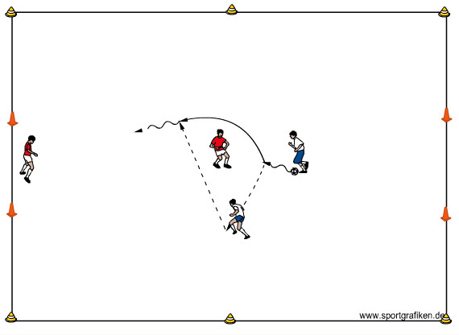
2) 2v1+1 to goal
In a 12x17 yard grid add two 3 yard goals on each 12-yard side. The attacking team looks to combine (over-lap, take-over or wall pass) or attack on the dribble or shoot (knee height or below). The defending team must have one player in the goal and one on the field. The goalkeeper must stay in the goal until the attacking team loses the ball, then the player that was in the goal can come out to attack (while the team that just lost possession must send one player back to play in goal). (15 minutes)

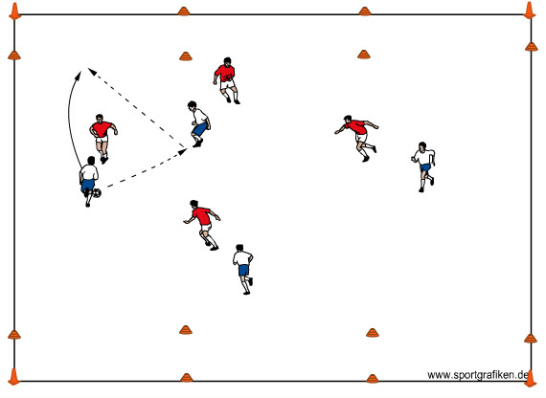
3) 4v4 to 5v5 to end zones - - Set up a 30 yd x 40 yd field with end-zones behind the 40 yd lines.
Teams comprised of 4-6 players depending on numbers and space. The attacking team may dribble into the end zone or combine with a wall pass, take-over or over-lap to get into the end zone (marked with discs). Version 2: Add a “plus” player who always plays for the attacking team if they can’t keep possession long enough to create a combination or opportunity to score on the dribble. Also, coach can give more points to encourage more dribbling if necessary or more points for passing if necessary. Variation 3: Coach can limit touches-3 touch, 2 touches, and 1 touch. (20 minutes)

4) 6v6 to 7v7 or 8v8 Scrimmage - - Depending upon numbers, space will change. Ideally, finish with the number you normally play with in games. Play a regular game with goalkeepers. (30 minutes)

5) Cool-down - - Groups of 5 Relay Heading Challenge. One player stands on the line with the ball in their hands (server); the other 4 players positioned directly across from them (about 3-5 yards away), one behind the other. The server tosses the ball to the first person in line. The first person in line heads the ball back to the server, then goes down on one knee. The server then tries to head it back to the second person in line, who heads it back, goes down on one knee, etc. Give the server multiple chances to get the ball all the way down the line. Switch up players to ensure everyone gets a chance to be the server. Finish cool-down with static stretching of major muscle groups. (10 minutes)

U11 U12

Objectives: To help our players to understand the importance of passing and receiving, along with individual, group and team shape when their team is in possession of the ball. A players shape and how it is coordinated with teammates in the area around the ball, as well as teammates away from the ball, is crucial to the attacking success of the team. The quality of the pass and being able to receive with a good first touch away from pressure, or to attack space in front of you is crucial to individual and team success. The decision of the passer on where and when to pass to his/her team mate.

Coaching Points
- Survey the playing area at all times so that you can anticipate what to do next with and without the ball
- Keep body open to as much of the field as possible based on where you are on the field
- Take first touch toward a passing option
- Strike ball with proper weight and proper surface
- Develop & keep individual and group shape
- Develop rhythm of play in traffic
- Increase speed of play in traffic
- Recognize visual cues such as body shape of teammates, supporting positions and high option with the added pressure of more players on the field
- Develop & keep individual and group shape under the pressures of a game
- Develop rhythm of play based on what the game presents…increase speed of play at the right time
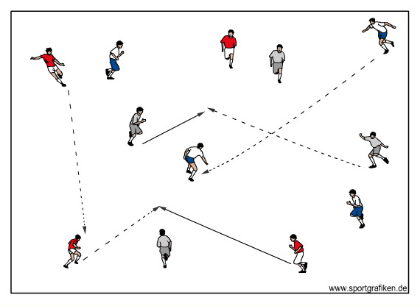
1) Inter-passing in 4’s or 5’s - - Players are in color-code groups of 4 (4 blue, 4 red, etc.). Each group has one ball. Each group passes and moves in free space, playing through the other groups. The purpose of this warm-up activity is to clean up the mechanics of passing and receiving, increase the players’ technical speed and develop basic individual and small group shape. You must insist on a quality 1st touch and appropriately weighted passes. (10 minutes)

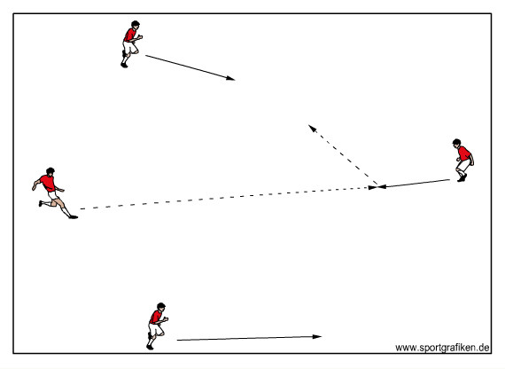
2) 4 v 0 or 5 v 0 Pattern Play - - In a 30yd x 40yd grid, one of the 4 or 5 player groups moves the ball from one end of the grid to the other. In this activity, the point is to move the ball effectively and quickly, while the players maintain their positions and a “kite-type” shape. The idea is to have 2 wide players supporting the player with the ball and one high player for a long pass option. The players in the area around the ball make 4-5 passes before looking long to the high option. Once the ball is played to the high option, the 2 wide players move to support the ball at the other end of the grid. (15 minutes)

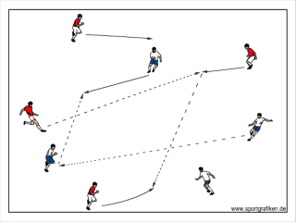
3) (4 v 0) + (4 v 0) - - Two groups of 4, with 1 ball per group, play through each other in the same 30yd x 40yd grid. Each group simply focuses on their ball, their individual & small group shape and their speed of play. Neither group attempts to disrupt the other. (15 minutes)

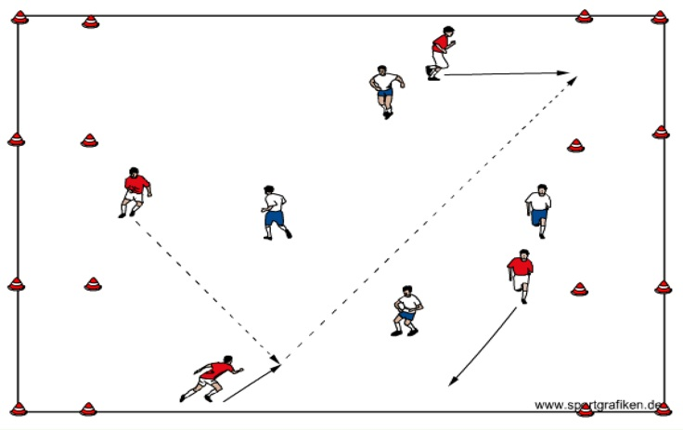
4) 4v4 or 5v5 to Zones - - In the same 30yd x 40yd grid, add 30yd x 5yd end zones at each end. Play a 4v4 or 5v5 game to end zones. Each team defends one end zone and attacks the other end zone. If a team successfully plays a ball into the end zone opposite them to a teammate, they receive one point (the player must arrive in the end zone as the ball arrives…NO attacking player is allowed to “hang out” in the end zone). The defending team can only defend in front of their end zone…they cannot enter the end zone that they are defending. (15 minutes)

5) 6v6, 7v7, 8v8 Game - Play the larger game. If playing 6v6, the field size should be approximately 45 x 60 yards. If playing 8v8, the field size should be approximately 55 x 80 yards. Encourage your goalkeeper to communicate to the team regarding team shape. Emphasize the coaching considerations made throughout the training session. (25 minutes) Stay on topic.

6) Cool- down– Controlled juggling (thigh-thigh-foot-foot). Statically stretch the large muscle groups.
(10 minutes)

U11 U12 Combination Play

Objectives: To help players to recognize when to combine with teammates and what combination is appropriate (wall-pass, overlap and take-over) considering the changing conditions of the game.

Coaching Points:
Wall pass:
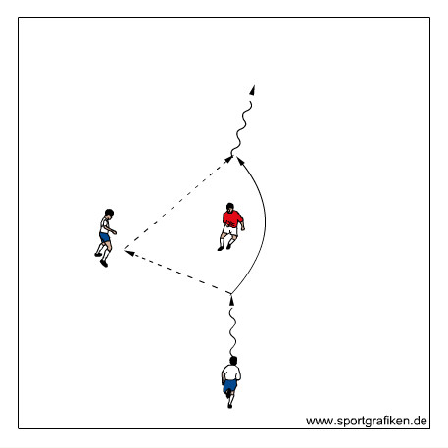
- First attacker runs right at the defender with the ball
- The second attacker sets up level with or slightly ahead of the defender, turned sideways, shoulders pointed to the goals
- When the first attacker is close to-but still out of tackling range of-the defender, he/she must read cues from the defender
- If the defender is jockeying between the two attackers and obviously playing the pass, the first attacker must simply dribble past the defender with speed
- If the defender is attending more to the first attacker, then the first attacker should pass the ball to the wall player’s (2nd attacker) front foot
- The 2nd attacker plays the ball with one touch into the space behind the defender and into the running path of the first attacker
- The 1st attacker sprints to receive the ball preferably in the natural flow of her run
Overlap:
- The first attacker plays the ball to the second attacker who dribbles in a direction away from the overlapping space
- The second attacker dribbles to create overlapping space and the first attacker then becomes the player who overlaps. The ball is played into the running path of the first attacker
Takeover:
- The 2nd attacker runs directly at the 1st attacker from the opposite direction
- The 1st attacker protects the ball from the defender by keeping it on the foot furthest from the defender so that his body is in between the defender and the ball
- If the takeover is on (if the defender does not step into path of second attacker), the first attacker leaves the ball for the second attacker and the second attacker
takes the ball using the same foot as the first attacker (right foot to right foot, left to left!)
- Depending on your preference as a coach you may have the first or the second attacker dictate this exchange with simple communication
- If the defender slows down to “pick-up” the 2nd attacker, 1st attacker can call his or her name and continue to dribble

Activities coaching points:
- Help players recognize when to combine and when to fake the combination to beat the defender
- Assist players in seeing that, when they combine, their ultimate goal is to get their pass in and behind the defender (vs. in front of them)
- Reinforce positive decision making opportunities (decision to combine or not, what type of combination, how effective at the time and place on the field, etc.)

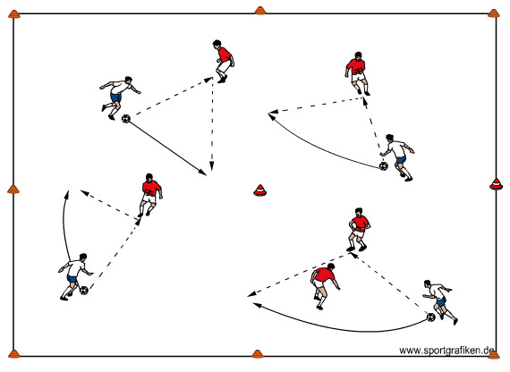
1) Combination Square - - Make a grid about 30yds x 30yds and break it into quarters. Place 4 or 5 players in red vests and have them roam around the entire grid in order to give support to the other players. Players in vests do not have soccer balls, while all other players do. Players with soccer balls look to dribble around the grid and try to connect with the vested players to perform wall-passes. However, in order for this to happen the player on the ball must pass to a vested player in a different quarter than him and the pass back from the vested player must go into a quarter that neither he nor the player who passed the ball is in. The player initiating the wall pass needs to play a firm pass, sprint to an open space in a different quarter, receive the return pass, and look for another player to combine with. The vested player must show themselves to others constantly in order to give support and look to play balls to the front foot of the runner. (10 minutes)

2) 2v1+1 to goal - - In a 12x17 yard grid add two 3 yard goals on each 12-yard side. If the attacking team combines before they score, they are awarded 2 points. If they don’t combine and score, it is worth 1 point. The defending team must have one player in the goal and one on the field. The goalkeeper must stay in the goal until the attacking team loses the ball. (15 minutes)

3) 4v4 to end zones - -In a field space approximately 30 to 35 yards long by 40 to 50 yards wide, teams comprised of 4 players depending on numbers and space (can increase or decrease from 3v3 to 6v6). Teams receive 5 points if they combine with a teammate before successfully entering the opponent’s end zone; they receive only one point if they get in without a combination. Add a “plus” player who always plays for the attacking team, IF they can’t keep possession long enough to create a combination or opportunity to score. (15 minutes)

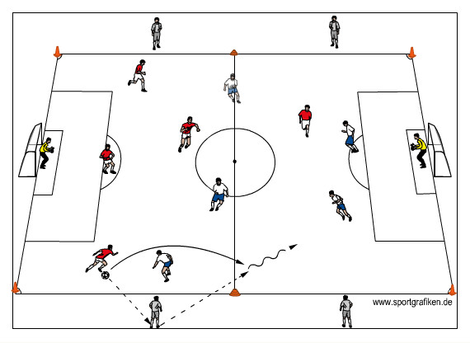
4) 5v5 + 2 to GKs + 4 Bumper Players - - In a field approximately 55 yards long by 40 yards wide, play 6v6 to goals, with goalkeepers, and position 2 Bumper players (neutral players) on each sideline (neutral players can move up and down the sidelines). Play a regular game…the 4 neutral players always play with the attacking team (team in possession of the ball). This activity will stimulate combination play. (20 minutes)

5) 6v6,7v7 8v8 Scrimmage (25 minutes):
In a field approximately 75 yards long by 50 yards wide, play a regular game with goalkeepers. Depending upon number of players that you have at training, field size may change. Ideally, finish with the number you normally play with in games.

6) Cool-down (5 minutes):
Individual juggling; challenge the players to see who can juggle the most in a 2 minute period.

U11 U12 Defending Pressure and Cover

OBJECTIVE: This session is designed to teach the defenders closest to the ball when, where and how to win the ball back for their team. In particular, we will discuss the roles and responsibilities of the pressuring defender (1st defender) and the covering defender (2nd defender).

Coaching Points (1st Defender):
- Angle of approach – We want to direct the player one way on the field, take away option of advancing forward.
- Speed of approach – Approach fast…arrive slow
- Body Shape- knees bent, on the balls of their feet, one foot slightly angled in front of the other foot
- Decision to delay opponent or to tackle the opponent to win possession of the ball; if 1st defender does not have good cover, delaying the opponent is a good decision; if the 1st defender has good cover, then the decision to tackle with the toe-poke or block tackle is appropriate just as the ball comes off the foot of the dribbler

Coaching Points (2nd Defender):
- Angle and distance of cover; speed to cover – Stay connected to first defender
- Cover dangerous space between 1st defender and you; cannot allow a penetrating pass to split you and the 1st defender!
- 2nd defender must recognize their responsibility to cover the 1st defender as the ball is traveling to the opponent (1st attacker).
- Be positioned so that, if the 1st defender gets beat with the dribble, you can become the 1st defender immediately.
- Be ready…see the ball, keep feet moving

Mistakes to watch for
1st defender: (these are common mistakes that we want to watch for and correct.)
- Planting their feet once they get to the defender
- Sprinting straight at the attacker (diving in)
- Standing straight up
2nd defender:
- Running right behind the 1st defender
- Running next to the 1st defender and creating a flat shape
The team:
- Players hanging back and not pressuring the ball as a team when they become defenders

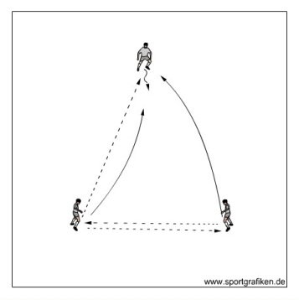
1) Pressure-Cover Warm-up - - 3 Players per ball in open space. Player A inter-pass with Player B, about 8-10 yards apart. Player C is located about 10-15 yards away from Players A & B. After 3-4 passes, Player A passes the ball to Player C. While the ball is traveling, Player B approaches Player C to apply pressure to the ball; at the same time, Player A provides appropriate cover to Player B (positions herself behind and at an angle to Player B. Player C attempts to split Players A & B with a dribble or a 1 touch pass. Repeat many times, changing the roles of the 3 players. (10 minutes)

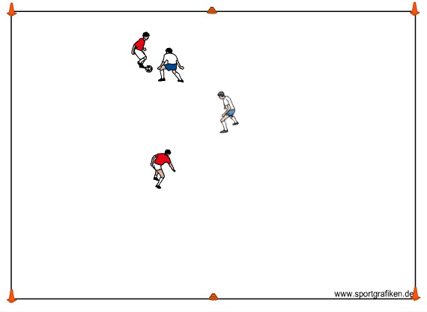
2) 2v2 to lines - - Create multiple fields that are 20yds x 15yds with 6 cones outlining the field (enough so all players are playing); organize all of the players into teams of 2. Each team will attack the end line opposite them and defend the end line behind them. Players must dribble over the opposite end line to score. Play a tournament format where teams play 2 minute games and then rotate to another field. Scoring goes as follows: 3 pts for the win, 1 pt for the tie, 0 for a loss and, if they have a shut-out, they get 2 bonus pts.
Note: Play with offside. (20 minutes)

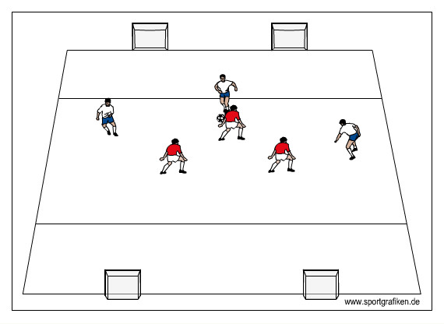
3) 3v3 Four Goal game - - In a grid 20x30 yards with four goals measuring 3 feet across in each corner, play 3v3. Each team attacks the 2 goals opposite them and defends the 2 goals behind them. Some questions to ask the players: “can you channel the ball into certain areas of the field to gain possession?” “Can you apply enough pressure on the ball to limit the first attacker's options and make the play predictable?” Version 2: If the players are scoring very quickly, change the game so that the attacking team has to score by dribbling through one of the goals; this will allow the defending team more time to get organized. (25 minutes)

4v4, 5v5, 6v6 Game with Gk’s - - Unrestricted play. As the game is going on, praise successful defending and connection by the 1st and 2nd defenders. (30minutes)

U11 U12
Coaches should plan their own sessions from the samples provided. Be creative and make your lesson plan using your own ideas. Create your own activities based on the 1v1, 2v2 and 3v3 games. Always end with a 5v5,or 6v6 game. You may also use any activity from the younger age group listings. Just adapt to suit the level of your players. Ensure there are lots of touches for everyone by creating multiple 3v3/4v4 games side by side.

Summary
I hope you find the information contained in this manual helpful and that it not only provides you with some ideas on how to present the game to the players, but also that you found it educational.
Should you have any questions please do not hesitate to contact me at
glenbuckleysoccer.com
gbuc200398@aol.com or glen@glenbuckleysoccer.com
Thank you and remember, Have FUN!

glen buckley soccer llc

Glen Buckley BIO
If you are serious about soccer then as a player, coach, administrator and parent you need to expose yourself to quality information and instruction. Glen Buckley has grown up around the game and made it his life. He has amassed close to 30 years of experience in the coach education and player development arenas.
His early days were spent in his native England learning his trade working for his home town club Wigan Athletic as Youth Team and Center of Excellence Director. He has worked for The English Football Association, and Lancashire Football Association. When his playing career was over he focused his attention and devoted his adult life to further education. He gained his FA “Full Badge” at just 27 years of age. He was selected as one of the first 30 coaches in England to be a Tutor Assessor of the FA, shortly afterward completing his UEFA A license. Following successful stints as a manager in the Semi Pro leagues and scouting for numerous professional clubs he arrived on these shores in 1994 to take up a role as a Club Director of Coaching in Minneapolis, MN. Following 5 years in that role he was appointed State Director of Coaching for the New York State West Youth Soccer Association, a position he held for 10 years transforming the state coach education program into one of the most successful in the country. During this period he successfully acquired the USSF A, B, National Youth License and the NSCAA premiere diploma.
He currently serves as both a US Soccer and US Youth Soccer National Staff Instructor.
He has recently set up glen buckley soccer llc an education and consulting company offering individual and team training, coach education, club development and key note speaking nationwide.
If you have been in his classes or attended his clinics or lectures then you will fully understand his infectious personality and will certainly appreciate his quick wit. His knowledge is unsurpassed and is delivered with a calm and controlled demeanor that both players and coaches welcome and appreciate, normally with a smile on their face!

Mission Statement: "To provide the youth of Watertown the opportunity to participate in recreational and competitive soccer leagues by teaching and demonstrating soccer skills, sportsmanship, honesty, respect, and fair play. To provide a safe environment where our youth not only can excel in their soccer skills but also learn the importance of physical fitness in their lives. To provide an atmosphere where the player’s emotional well-being will be nurtured as they learn the importance of teamwork, determination, persistence, and hard work. All members will work towards instilling in our youth the enjoyment and fun aspects of the beautiful game of soccer"
Association Information and Contacts:
WYSA Officers:
Jason Bartels President
Dan Dahl Vice President
Lisa Kieso Sec/Treasurer
Milt Carter Past President
Executive Director
Kelly Roby 605 868 1369 Director@watertownsoccer.com

WYSA Board of Directors
Jeremy Ebsen
Rose Derby
Heidi Fiechtner
LuAnn Strait
Casey Feinenger
NOTES:

Notes

Notes

