Coach Learning and Reference Manual

For coach/facilitators
of
U13 through U18 players

Training and Game Day Guide

Contents Page
Welcome and Introduction Glen Buckley 3
Parent Meeting Agenda 5
Age Group Characteristics and Skill Priorities 6
Methodology:
The Four Components of the Game 8
Economical Training 9
How Do Children Learn? 10
Guided Discovery 11
Practice Organization 14
The Coaches Toolbox 15
Lesson Plans / Activities U13-U14 17
Lesson Plans / Activities U15-U18 31
Summary/ Contact 47
Glen Buckley Bio 48
Mission Statement and Association Information 49

Welcome and Introduction Glen Buckley
I was both honored and flattered to be asked to work with the Watertown Soccer Association and to put together these manuals. To be associated with such an innovative and forward thinking club whose primary focus is in the development of young athletes in the sport of Soccer, and life itself, was just too good an offer to refuse. Coaching young players and introducing them to the sport of Soccer can be a very frustrating yet extremely rewarding experience. Over the coming months I look forward to working with you to enhance the experience of both the players and coaches within the club.
It is my intention within these pages to minimize the frustrations and provide you with enough information to maximize the “Fun” for both the players and the coach. Understanding the players and their age characteristics, along with creating the correct age appropriate training and game environment is paramount in the development of both player and coach. Please think of yourself as a “facilitator” rather than coach. You will present the “game” to the children and challenge them to resolve the problems that the game presents. Children love to solve problems. We adults have a tendency to forget that and want to give them the answers. Telling them to shoot, boot it, go to it and hustle are all things that they are more than capable of working out for themselves! We just have to allow them the time to do so. Some will work things out quicker than others, we have to be patient, and they will get there in the end.
The main focus for the U13 and U14 age groups is still their comfort with the ball, so lots of repetition on the fundamental technique. It is now important to provide opportunities for the players to understand the where, the when and the how. Choosing the correct technique on demand and the ability to execute that correct technique at the right time and into the correct area can be taught through the small and large group activity training structure. The players that are putting the time into practice away from the organized structure will begin to stand out technically above the others. Players should be encouraged to practice with a ball at home.
The U14 through U18 age groups are the ages of understanding and tactical awareness. The players will begin to create an identity for themselves. Some will show a natural understanding for specific roles i.e. defenders, midfield- players or attackers You will find some functional sessions that are specific to the various thirds of the field. It should also be noted that players of this age are either in or about to begin a growth spurt. Players that in adolescence were coordinated and sharp become the opposite. Patience should be afforded these players. They will come again when everything falls back into place and they have grown back into their bodies. Co-ordination exercises are a good addition for 10 to 15 minutes during your practice. Throw, bounce pass on the half volley back to a server etc, are great additions to your regular warm up routines. These create eye and foot co-ordination training.
The use of Guided Discovery as a teaching tool is explained and will help you in setting the correct environment and atmosphere during your sessions.
The activities here are age appropriate and have a proven track record in player development. I encourage you to use them as a base for your practices, but you should also be creative and try some of your own ideas. Try a selection of activities from the sample plans to create your own session. If your team is not ready to move on then don’t……..repeat the session. The more players in an activity the more difficult it is for the players to have success. Decisions are harder and the space and time to make them is smaller and shorter. At this age following a technical warm up, I would suggest that your small sided activities begin at the 3v3 level. Running two or three 3v3, 4v4 games side by side is better than an 8v8 or 9v9, where no one gets enough space or touches and so less chance to make decisions. The degree of difficulty can be changed by adding *neutral players or players on the outside of the activity [Bumpers on the outside or Targets on the ends] to set the players problems to solve without adding more players to the field of play. It is also important to note that the size of the area should be adjusted to suit the level of play. If the ball is constantly out of play, or is contested after every first touch then make the field bigger. If every second touch is a tackle or competition with an opponent then your player’s level of play requires more space to allow a second or third touch and even a shot or pass. As they get better make the area smaller. The Coaches Tool Box is a method in which to give information to the players during practice and games that is less intrusive. We are attempting to give the game back to the children. Practice it in conjunction with Guided Discovery and you will see a better flow to your sessions.
Remember NO Lines, NO Laps and NO Lectures. Play small sided games in practice.
Please enjoy your time as a coach if you work at it, it really can be a very rewarding experience, just don’t take yourself too seriously and smile……your players will appreciate it.
*Neutral Players. A neutral player is a plus player that plays for the team in possession. 3v3 plus 1, the one being the neutral player.

Sample Parent Meeting Agenda . Have the schedule of all practices and games and the weather/medical emergency plan attached to these agendas. Adapt the following to suit the age and competitive level of your group.

Team Goals: Our primary goals as a team are to have fun and to develop as young soccer players. I hope to be able to teach the players needed skills that will help them improve in the game. We will have fun practices that focus on technical skills. Winning will not be a priority for our team. Team priorities will be developing skills and enjoying the game. If you watch practice you may at times see us engaging in activities that do not look like “real soccer”. Please be assured that all activities we do will help with skill building, motor development, and enjoyment.

Style of Play: I will be encouraging the players to try new things and to be creative. We will focus primarily on developing dribbling skills, and also spend time on passing, receiving, and shooting skills so players begin to develop in age appropriate skills. It is my hope that players have the confidence to show their skills in the game and improve their comfort in possession of the ball. We will try to move up and down the field as a team and I may, on occasion, move players into different positions to help them learn all parts of the game. We will spend most of our time on skill development.

Attendance: I will be at every practice and game, foregoing any unforeseen emergencies. Please make every attempt to have your child at every practice and game (on time) as it is part of learning the responsibility of being on a team. Given our hectic lives, I do understand that players may have conflicts here and there. Please let me know before the first game of any conflicts you might have for the season so I can prepare my practices accordingly and we can make sure our team has enough players at every game. Please have your children at the field ???? minutes before the game starts and please pick up your children promptly after every practice and game.

Discipline: I have been told that I run a tight ship and will continue to do so. If players are acting out, I will ask them two times to fix their behavior. If they fail to do so after these warnings, I will sit them down at practice or during a game. If the behavior continues, we will need to talk about it to find a way to help resolve the behavior best without it detracting from the rest of the players’ experiences on the team.

Communication: I am typically a difficult person to reach by phone. The best way to contact me is via email at soccercoach@sampleclub.com. Should you wish to talk by phone, my office number is 1-800-852-6666 and the best time to reach me is between 12pm and 3pm. If these times do not work, let’s schedule a time that works for both of us. Please do not ask to talk to me during a practice or game or immediately before or after the game or in front of your child. I do encourage open communication and questions as we all hope to make this a great experience for the children.
Sideline Behavior: Please be supportive and enthusiastic on the sideline during games. The players and I will truly appreciate your applause and encouragement. However, if everyone is coaching, this will only confuse the players. Please do not coach from the sideline. The players need to make their own decisions and we need to support them and educate them at practice. Remember, you are a role model on the sideline for the players. Please set a good example.

Overall: I am excited for a great season and I hope you and your child are as well. Let’s all have fun and enjoy the game. If you have any questions, please, let’s keep open communication.

Player Characteristics 7th and 8th Graders

Typical Characteristics of U13/U14 Players

- Increasingly able to move quickly and appropriately without the ball.

- Concerned about their body and how it appears to others.

- Increasingly appreciate effort as a factor in evaluating their performance (better able to distinguish between performance and outcome).

- Likely to use internal standards in evaluating themselves.

- Less willing to accept criticism.

- Seeking autonomy (may be critical of authority).

- Finding their identity (may experiment with other roles, activities, and interests).

- Able to think in abstract and hypothetical terms (better able to grasp strategic and tactical aspects of the game).

- Girls generally nearing the end of the growth spurt and sexual maturation. Rates of maturation may vary.

- Boys generally at the beginning or in the middle of the growth spurt and sexual maturation. Rates of maturation may vary.

- Strongly influenced by peer interactions (more so than by interactions with parents and other adults).

Age Group Skill Priorities

U-13
Field Players Goalkeepers
Continue with all U-12 focus Proper positioning
Basic combination play Breakaway and tipping high balls
Proper 2v2 defending and attacking Punting and goal kicks
Increased technical speed of play
Ability to chip the ball
Accurately play long passes
Basic understanding of roles of 3rd defender and attacker

U-14
Field Players Goalkeepers
Continue with all U-13 focus Advanced distribution
Increased technical speed of play Collapse diving
Ability to play accurate, driven crosses Receiving & playing ball w/feet
Introduction to transition play Organizing defenders
First touch finishing
Full understanding of roles of 3rd defenders and attackers

Player Characteristics 9th through 12th Graders

Typical Characteristics of U15 – U18 Players

U15 –U18
Field Players
Continue with all 14 year old focus
Increased technical speed of play, recognition of pressure and how to get out of it
Recognition of when to play one touch, or no touch
Ability to play accurate, driven passes and crosses
Understanding of transition play
First touch finishing
Full understanding of roles of 3rd defenders and attackers
Better understanding of space and movement away from the ball to create space for themselves or team mates
Better understanding of the roles in each third of the field
Fitness, stamina plays an important role in the outcome of games
Increased ability in self- analysis of performance

Goalkeepers
Advanced distribution, and Communication
Collapse diving, full stretch take off
Upper body strength / deflecting / catching
Receiving & playing ball w/feet
Organizing defenders
Playing sweeper, awareness of space between line of defenders and themselves
Better decision making
Brave

METHODOLOGY

The game of soccer can be easily broken down into four components: technical, tactical, physical, and psychological. Whenever running a practice we should do our best to insure our activities include all of these components. Although we should try to incorporate the four components into all of our activities, we also need to recognize it is important to teach and coach in a manner that is appropriate to both age and ability. Here is a description of each of the four components:

Four Components of the Game

Technical

Technique is the mastery of the ball using various body parts. Skill is the application of that mastery during the course of a game. At the U12 and U14 age levels, players need to continue to work on their technical proficiency and should be placed into situations that will increase their ability to manipulate the ball when under pressure. Technical proficiency needs to be shown at full speed and with defensive pressure.

Tactical

Tactics are the parts of the game in which players have to make on and off the ball decisions based upon the position of teammates, opponents, where the ball is, where they are on the field, and where the goals are in relation to the ball or themselves. The U12 age group is often referred to as “the dawn of tactics.” Players in this group should recognize width, depth, support, combination play, and the roles of the 1st, 2nd, and 3rd attacker and defender. U14 and above is a continuum of these understandings, with more detailed comprehension given to 3rd attacker and defender.

Physical

Each player has physical attributes such as strength, speed, agility, size, quickness, and endurance. These areas can be maximized, but are limited by the genetics of the athlete. At different ages, the development of different parts of the physique should be emphasized. At these ages, the players need to know how to stretch properly and we should focus upon aiding their balance, coordination, and agility. Players at these ages do not need strength training.

Psychological

The psychological aspect of the game refers to the mental portion of the game. This includes competitive mentality, optimism, leadership, and overall attitude among many things. The mental make-up of athletes can have a vast effect upon their performance and their enjoyment of the sport. Coaches and parents can have a large affect upon young people’s attitudes towards sport, and their opportunity to enjoy the game. Teambuilding becomes important at these ages, as does teaching our players to be resilient. Between U12 and U14, roughly 75% of players will quit playing soccer. This dropout rate is seen across all sports and is a startling number we need to be aware of at all times. These players need to be allowed to have fun and soccer should be enjoyable above all else. If we fail to create this environment, we need not talk about any of the components of the game, as we simply will not have children who are willing to play.

Economy of Training

Training economically means the inclusion of more than one of the four components of the game into the same activities within a training session. An example of an uneconomical practice would be running for a whole practice. Fitness might be improved (though injuries increased); however, players would not improve tactically or technically. An economical activity at practice such as ball tag would include the manipulation of the ball (technical work), turning, stopping, and running (physical), decision making (tactical), and if the coach sets the environment for success, confidence can be built by the coach (psychological). With the little time we spend with players, economical training is a must.

How Do Children Learn?

Children learn by knowledge of results.
Not the winning and losing, or by points gained type of results, but the result of doing. If a child tries something and is successful, they are more likely to want to do it again. Repetition is the key. Practice Makes Perfect is a phrase we have all heard and used. However caution should be taken as practicing the wrong thing may make you perfectly bad at it! Maybe we should change the phrase to Practice Makes Permanent. The point being that the correct environment and correct practice is essential to learning.

Learning.

It is critical for us to recognize children have varied learning styles. Some children learn optimally when they hear things described to them. Others learn best when they see things. However, other children learn best by doing. Depending on the source, estimates claim 20-30% of children may retain information they hear and, possibly, up to 45% of children retain what they see. This is compared to 80% retention of what they do. Here are brief descriptions of the varied learning styles of children:

Auditory Learners

Auditory learners learn best by listening. They often understand the nuances of speech we convey through tone, speed, or pitch. You might see these children reading aloud in school as they learn best by hearing. On the field they will listen intently to your words. It is important you provide clear, concise, and direct instructions.

Visual Learners

Visual learners learn best by seeing. They will benefit most not from your description of activities, but rather by seeing a demonstration. The adage “a picture is worth a thousand words” is often very true to visual learners. In school, these children prefer diagrams and overheads. On the field, they prefer to see what they need to do.

Kinesthetic Learners

Kinesthetic learners learn best by doing. The large majority of your players will excel through this means of learning. Children in kindergarten and early elementary school are especially likely to learn this way on the soccer field as it is the primary method of learning in life for them. They learn through exploration and touching. You may actually find some children who are easily distracted unless completely engaged.

Overall, we need to make sure all of our players understand the messages we are trying to provide. The important thing to note is the large majority of players will understand most easily by doing. Therefore, we need to make sure they are active as much as possible. Giving brief directions, providing a clear and simple demonstration, and then having the players engage in the activity will prove the optimal method of teaching. By doing this, we quickly cover all types of learning. However, if your description is too long, you will find you have lost some children before you even start. A brief description is key. Once you get the children playing, you can give personal attention to players who do not understand while the remainder of the players are actively engaged in the activity.

Guided Discovery

If you listen to the words shouted from the sideline of a typical field, you are likely to hear many specific directions from coaches and spectators alike. Every time a child receives the ball, they are likely to hear at least 3 or 4 people telling them what to do. We then see children kick the ball forward as hard as they can or run with it as fast as they can seemingly without any thought. They do not do this because it seems like the best choice. In fact, it is unlikely those players even ask themselves what the best choice of action is in that situation. Often, they are simply doing what they are told to do by the shouting coach or spectator.

If we asked these players to explain their decisions to us at the end of the game, or even immediately after their actions, it is unlikely they would be able to provide us with a rational explanation as to why their actions were warranted. If these players are placed in the same situation at a later time, they will not have a thoughtful knowledge base from which to draw upon when trying to solve the situation. It could be that they make the same mistake when placed in the same situation. Otherwise, they could simply choose a different response randomly in hopes they will eventually find something that works. By the time this trial-and-error method of solution proves fruitful, it is likely the player will be so frustrated they do not want to play anymore.

So what can we do as coaches to prevent players from making the same mistakes and feeling growing frustration? We could continue to yell louder and hope they listen to us constantly when playing. Of course, then it does not really seem like they are playing. Rather, it seems we are puppeteers using our players as puppets. Our challenge then is to help provide the players with the tools to make these decisions for themselves while on the field. If our players understand when it is best to kick the ball forward or to run forward with the ball and why they are making all the decisions they are making during a game, then they will be able to improve their own play (even during the game) and be rewarded with success. Further, if they become thoughtful, strategic players, they will have more fun, gain confidence, and your team’s performance is likely to improve continually.

By asking our players questions to which they must come up with answers, we can insure that our players are thinking, as opposed to mindlessly following our directions. Of course, if we do not ask guided questions, we may find ourselves and our team roaming aimlessly amidst philosophical clouds. By asking guided questions, we can help maintain focus and direction for our team and help provide learning experiences for our players.

When referring to guided questions, we mean our questions should place our players on the right track (guide) in order be able to solve the questions we pose. Some questions may be quite direct and simplistic such as:

- What part of the foot do you use to make a short pass?
- Where should you aim when shooting on goal?

Questions such as these are called “low order” questions as they demand factual, memorized answers. In contrast, we could ask “high order” questions that challenge our players a bit differently by asking them to weigh options within the framework of a larger process. High order questions beg interpretation and comprehension over memorization or recall. Examples of “high order” questions include:

- How can you get the ball down the field quickly?
- How can you protect your ball?

Utilizing questions such as these will help our players learn and retain information that will aid them in making optimal choices as they play. It is not better to ask “high order” or “low order” questions, as they both serve helpful roles in learning. Our task as coaches is to find the proper balance of “high order” vs. “low order” questions for each of our players. In consequence, rather than waiting for us coaches to fix errors of play at half-time, our players will likely look to solve errors immediately during the game as they have been trained to do so in practice.

As mentioned earlier, an enormous benefit of asking questions such as these may be how players develop confidence and learn to trust their own decisions. Of course, we must temper the difficulty of our questions to insure they achieve the success necessary to help build their confidence. In fact, players may be a bit uneasy when asked these types of questions (especially high order) at first. For this reason it is a good idea to provide a few positive words before asking a question. For example:

- Great….so how could we do it faster?
- I like that answer…what other skill can we use to get the ball to our teammates?
- Now you’re getting the idea! Where could you position yourself so that you could see both the player you are defending as well as the ball?

Now armed with the confidence and skill to evaluate situations and make decisions on their own, these players will look within themselves (not toward the sideline) in order to determine what choice to make on the field. As they become skilled at answering these questions, they will be able to increase their quality and speed of play. This will allow us to sit back in our chairs during games and appreciate the fruits of our practice efforts.

Using this method of coaching, we can help develop more competent players and more confident people. Although coaches and parents alike may find their sideline shouting ignored as players gain competence, I think both groups would be happy with that result. Here are a few more examples of guided questions we hope you will try to incorporate into your coaching:

- In a 3v3 situation, what’s the best way to get the ball to your teammate? Let’s try it!
- What happens when you pass the ball behind your teammate? Let’s try it!
- Now, if you want to make sure your teammate goes forward, where do you want the pass to go?
- Why didn’t that pass work? So, how should we do it this time?
- How can we get the ball to the other side of the field?
- Why is it important for you to lift your head up when you have the ball?

Practice Organization

Coaches should organize their practice session in a progressive manner, easy to difficult or simple to complex. It must provide for individual, small group, large group and/or team activities. An example of a practice format would be:

A. Warm-Up – the warm-up prepares the player both physically and mentally for what is to follow in the training session. Warm-ups should incorporate a technical and/or tactical element as a lead in the training session. Stretching should be integrated throughout the warm-up.

B. Small Sided Activity – small group games that provide a lead into larger group games or activities. Small group activities will provide the majority of work within your coaching session and should cover your one chosen topic (not many different topics). This activity may be non-directional or directional and will continue providing the technical repetitions introduced during the warm up.

C. Expanded Small Sided Activity - small sided games that now include more players and closely resemble the game of soccer. This activity must be directional and include a goal (can be multiple goals, end-lines or target players). Your topic still needs to be focused and taught during this activity.

D. Free Game – this does not necessarily mean 11v11. It means a game (without any manipulations) including as many players as you can up to the number that play in your league games. A U12 team playing with 8-a-side in their league matches should try to end with an 8v8 scrimmage. Similarly a U14 team playing 11-a-side should end with an 11v11 game if possible.

E. Cool Down – following the training session a cool down of light, low intensity exercise and static stretching aids the player to recover from the training session. They have worked hard and this will help them to unwind physically and mentally. Could use co-ordination activities as a cool down

The Coaches Toolbox

During a session, a coach must recognize a “coachable moment” to give information to their players. A coachable moment is when a technical or tactical issue arises, based on the topic for the session. Each activity in a session plan will create a “coachable moment”. As coaches, we watch for these instances so that we can make our coaching points and teach our topics. With practice, coaches will learn how to find these coachable moments and recognize them in their sessions.

Once a coachable moment is recognized, there are several methods coaches use to give information to the players. These methods are called “the coaches toolbox” and are listed from the least to most intrusive. These methods are explained below:

Coaching Methodology

- Allow the conditions of the game to coach the topic
- Use touch restrictions (one touch, two touches, mandatory two touches)
- Adjusting the size of field
- Adjusting the size of goals
- Use a neutral player to provide a numbers up opportunity
- Let your players play the game
- Coach in the natural stoppages of the activity- ball goes out of play
- Wait for the ball to go out of play, then recreate the coachable moment
- Natural stoppages are throw-ins, goal- kicks, restarts from fouls…..
- Coach in the flow of the activity (large group)
- Direct information to groups of players, “push forward!”, “slide left!”….
- Information must be concise and clear to all of the players you are speaking to
- This is instruction, not a running dialogue with your team
- Coach individual players as the activity continues
- Talk to one player either from a distance or close
- Clear, concise information must be provided
- Have a player step out of the activity and you then provide them with short instructions
- Coach using the “freeze” method
- Stop play when the “coachable moment” occurs
- Players must stay exactly where they were when the “freeze was called”- if not, the picture of what is being taught changes completely
- Review what happened, rehearse what they could have done to find success, and restart play from a point prior to the point of your stoppage.

Regardless of the chosen method, remember to keep instructions short, detailed and topical (30 seconds for your coaching point). Paint a clear picture of what you want your players to do by reviewing what occurred during the run of play, rehearse the situation so your players gain

success with what you are teaching them and then restart play using what you rehearsed with your players.

As we coach, we need to allow our players to play the game. Making a maximum of four coaching points per activity, using any of the methods discussed above, will help keep your activity flowing yet still provide instruction to your players. We do not need to coach every mistake that occurs as we would be stopping play too often. Pick your times to make your points and teach your players!

Lesson Plans and Activities 7th and 8th Graders U13, U14

U13 U14 Passing for Possession

Objective/Purpose: Possession is the ability to keep the ball individually and collectively in small groups and as a team. The technical aspects of passing and receiving and the tactical aspects of movement and shape are key to our player’s success. The possession play of younger players tends to be slow, thus the numbers must be small so that the players can achieve success through multiple repetitions in a less cluttered playing environment. As players get older, play speeds up and they can handle activities with larger numbers.

Coaching Points:
- Proper receiving technique: good body balance, eyes on ball, body in-line with the path of the ball, movement to ball, appropriate touch on ball (cushion or propel)
- Proper passing technique: good body balance, placement of non-kicking foot, foot surface, ball surface, eyes on ball when striking, appropriate pace (weight)
- Surveying the area, intelligent movement, looking for target early, anticipation, keeping good body shape, head up, preparing to receive the ball, preparing to pass the ball
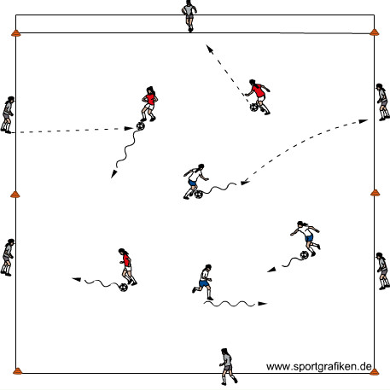
- Reinforce the roles & responsibilities of the 1st attacker (ball), 2nd attacker (support) and 3rd attacker (length or width) within the game. Especially, their responsibilities in keeping possession for their team (combination play) and penetrating into dangerous space behind the defense

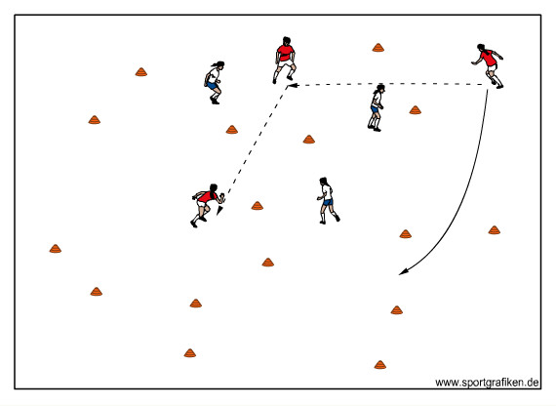
1) Inside-Outside - - One soccer ball per two players. Separate players into two groups. One group of players, without soccer balls, forms a 30 yd x 30 yd grid. These players are the outside players (Outsiders). The other group of players, equipped with balls at their feet, position themselves inside the circle. The players inside the circle (Insiders) dribble about the grid freely looking for an opportunity to pass the ball to a player on the perimeter of the circle (Outsiders). The Outsiders must one or two touch the ball back to the Insider. The Insider then controls the ball and looks for another Outsider to pass to. After approximately two minutes, the Insiders become Outsiders and vice versa. Variation: The Outsiders start with the ball in their hands. The Insiders move around freely inside the circle without a ball. The Insiders call for a ball from one of the Outsiders. The Outsider serves a ball (on the ground or in the air) to the Insider, who must one or two touch the ball to a different free outsider. (15minutes)

2) 3v3 or 4v4 Gate Game - - One ball. In an open area set up 6-8 gates (2 cones about 3 yards apart) at many different angles all over the field space. Organize players into 2 teams. Play keep-away in the field space. Points are awarded each time a team can pass the ball through any gate to a teammate and keep possession. The game is continuous constantly looking for another gate to attack. When the defending team wins possession of the ball they are on the attack. Play games to 5 points or for a certain time period (i.e. 5-10 minutes). Variation 1: Add more players to each team. As you add more players to the group, increase the playing space, add more gates and position the gates farther apart. (20 minutes)

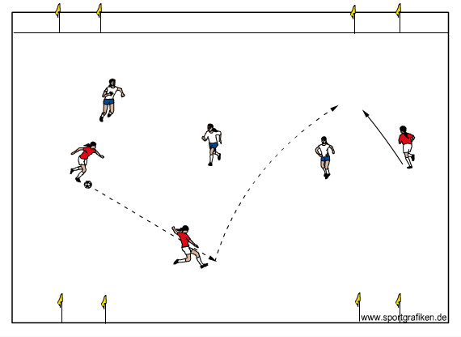
4) 3v3 or 4v4 To Four Small Goals - - In a grid 30yds x 35yds with small goals near each corner. Teams of three or four attack two goals and defend two goals. The goals are set up along the 35yd lines for extra width in the attack. Each team attacks the two goals opposite them and defends the two goals behind them. The goals are three feet wide and are placed near each corner. With three players, the attacking team should create a triangular shape. With four players, the attacking team should create a rectangular (diamond) shape. (20 minutes)

5) 5v5/ 6v6 Game) - Play the larger game to two goals with Gk’s. Encourage your goalkeeper to communicate to the team regarding keeping possession for the team. Emphasize the coaching considerations made throughout the training session. Stay on topic. (25 minute)

6) Cool Down– Controlled juggling (thigh-thigh-foot-foot). Statically stretch the large muscle groups. (10 minutes)

U13 U14 Improving Speed of Play

OBJECTIVE: To improve and increase speed of execution and speed of thought. Players must think ahead (anticipate) to decide what to do with ball and therefore play quicker. Players without the ball must always stay connected to the game. The session can be used for players from U12 and older. The older and/or better ability players the more demands we place on them. This is a 90 minute session.

Coaching Points:
- Quality of pass; proper weight, proper direction
- The quality of the support runs, angle, distance
- Speed of play. Gradually increase speed as performance improves
- Communication; verbal, visual, always thinking
- Stress speed of play and organization.
- Don’t take the same space as your teammate
- Quality of the 1st touch
- Communication; verbal, visual, always thinking
- Keep ball moving
- Outside players must move along the line and offer supporting angles
- Outside players must see the whole field and not just in front of them
- Team in possession must execute quickly using 1-2 pass, overlap and take-over
- Quick transition from defense to attack
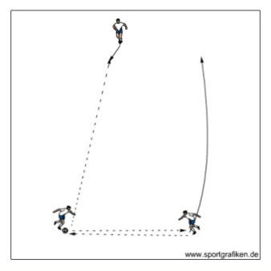
- Must transition from one half of the field to the other
- Must offer several passing options to target (corner) players
- Targets (Corner) players must recognize better option

1) Warm-up - - Groups of three players. B passes short to A, who passes long to C and follows pass and executes a 1-2 pass with C who passes long to B and follows pass and repeats process. After a few minutes of successful combinations have them execute an overlap instead of 1-2 pass. After a few more minutes, have them execute a take-over. (10 minutes)
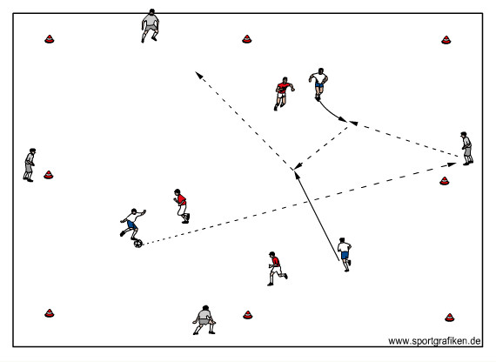
2) 3v3+4 or 4 v 4 + 4 - - In a grid, two teams play 3v3 or 4 vs. 4 inside the grid with the support of the 4 players (bumpers) outside the grid. Field size depends on players’ age, ability and training objectives. Outside players have one or two touches on the ball or two seconds. Five passes equals transition: When the team in possession completes five consecutive passes, they remain in the middle while the other two teams switch roles (play is continuous). Variations: (5 v 5 + 5, 6 v 6 + 6) (15 minutes)

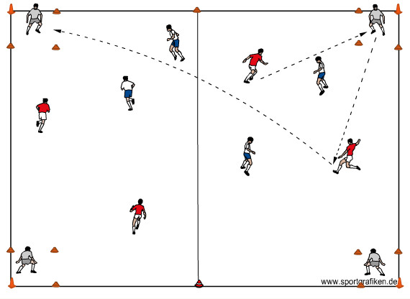
3) 4 v 4 + 4 Corner T’s - - The targets occupy the four corners (which are 5x5 yard grids made of cones). Ball must be played into a grid to a target player and back to the team that passed it in. Every time a team regains possession they must play a short corner first (that is determined by the ball being in that half of the field). After completing a short corner, the attacking team must complete a long corner by passing from the far half of the field to either of the other two corners on the other side of the mid-line. This completes the sequence. Two goal option: Award a goal for a complete sequence. After two goals the winning team stays in the middle while the other two team switch roles (play is continuous).
(20 minutes)

4) Play 6v6 or 8v8 - - Two teams play 8v8 including goalkeepers. A win is 3 points a tie 1 point and loss 0 points. Each team keeps score. Play games of 5 minutes or to 2 goals. describe a scenario that will put the pressure of time on one of the teams…i.e. With 3 minutes remaining in the game, the red team is winning by a goal; the blue team needs a draw to advance into the championship round of the tournament. (30 minutes)

Cool down - - A low intensity activity to help players unwind mentally and physically, including static stretching of the large muscle groups. (10 minutes)

U13 U14 Shooting and Finishing
OBJECTIVE: To help players recognize opportunities to finish from combination play. To help players develop the ability and the risky & aggressive attitude & instinct to score.
Possible combinations:
- The double- pass
- The overlap/run-around
- The wall-pass
- The take-over

Some general points:
- The players’ ability to recognize the verbal and visual cues of teammates is crucial to success
- The correct timing of runs and passes is crucial to success
- Appropriate angles and distance of support is crucial to success

Coaching Points:
- Stress passing and receiving techniques…use of the inside and outside of the foot, and the toe when passing and proper pace and accuracy of the pass
- Quality of the first touch
- Reinforce combination play coaching points
- Coach non-verbal cues…angle and timing of runs with and without the ball
- Work on technical speed
- Perfect communication
- Talk about visual cures
- Constantly survey the playing area
- Reinforce the combination play coaching points
- Talk about taking opportunities to score
- Be alert and ready to tap in any ball or rebound
- Reinforce following up all shots
- Talk about placement versus power
- Develop rhythm of play based on what the game presents…increase speed of play at the right time

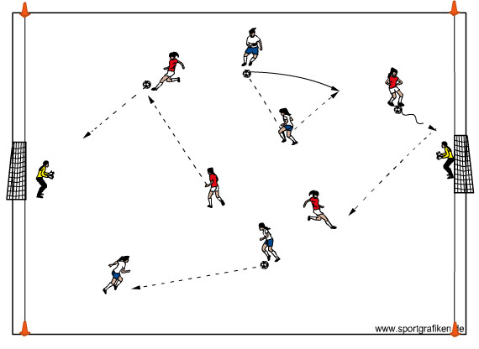
- Shooting Warm – Up - - Set up two goals about 40 yards apart and the width of the penalty area, with GK’s in each goal. (2 field players per ball) In pairs field players pass and move throughout the area experimenting with different combinations, finishing with a reasonable shot to the keeper (to warm the keeper up). (15 minutes)

Version 2: Pairs now try to score (after using different combinations).

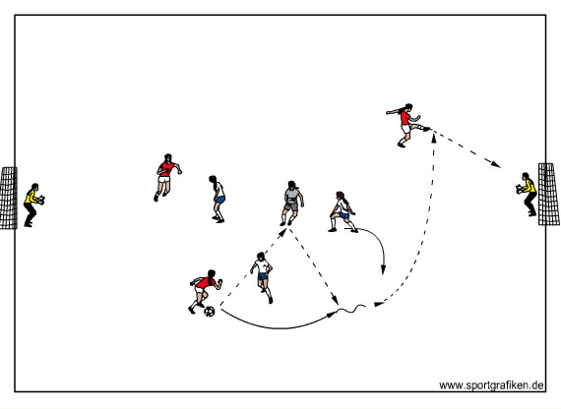

- 3v3+1 to goal - - On a field 30 yds wide X 35 yds long place two regulation size goals centrally on each end line. Play a game awarding 2 points for any goals scored from a combination play. Award 1 point for goals scored otherwise. The neutral player (+1 Player) plays with the team on possession. (20 minute

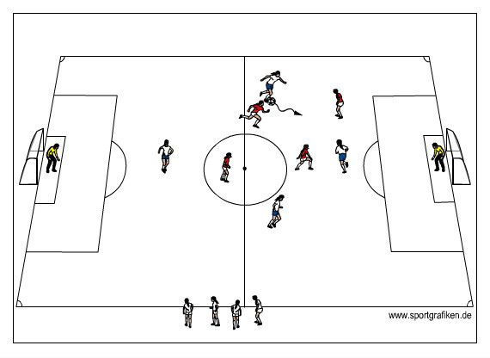
- 4vs4+4 on deck+2GK’S Two teams play soccer , on a field 30 yds wide X 45 yds long with regulation size goals centrally positioned on each end line. One team is on-deck waiting outside the field. First team to score two goals remains on the field, losing team is replaced by the on- deck team; or if two minutes pass by, and neither team has scored 2 goals or the game is tied, the team that has been on the field longest is replaced by the on-deck team. Captains on each team keep score.
(20 minutes)

- 8v8 or 9v9game - - In this game encourage the players to combine when in the final third and to finish as soon as they have the opportunity. Reinforce all the coaching points from the last three activities (30 minutes)

U13 U14 Small group Defending
OBJECTIVE: To teach the roles of the players who pressure, cover and balance defensively in relation to the ball and the 1st attacker and other attackers around and off the ball. Approach, angle, timing, steering of 1st attacker and the ball will be looked at in regards to the 1st defender. Aligning themselves in a covering position off the 1st defender will be looked at in regards to the 2nd defender(s). Lastly, ensuring balance and proper positioning from the 3rd defender(s) will be looked at.

Coaching Points (1st Defender):
- Angle of approach – Direct the player one way on the field, take away option of advancing forward
- Should begin to notice where their ‘help’ is behind them in order to know which direction to force them
- Speed of approach – Approach fast arrive slow
- Body Shape- knees bent, on the balls of their feet
- Front foot tackle vs. back foot tackle if the ball gets away from 1st attacker
- PRESSURE/DELAY

Coaching Points (2nd Defender):
- Position themselves ‘off’ the 1st defender in a position to cut off penetrating passing, dribbling and shooting options for the 1st attacker (30 to 45 degrees)
- Can compress the space between them if the 1st defender has ‘tight’ pressure on the 1st attacker
- Cannot compress the space as tightly if the 1st defender does not have ‘tight’ pressure on the 1st attacker
- Can track players immediately off the ball
- Can be more than one 2nd defender
- COVER

Coaching Points (3rd defender):
- Track attackers making runs away from the ball
- Provide balance away from the ball, so that a weak side pass will not become a huge advantage to the offensive team
- Tighten up the space in the center of the field to cut off passing, dribbling, shooting lanes for attackers
- Can compress the space if there is tight pressure and cover around the ball
- BALANCE

- Reinforce positive decision making opportunities (recognizing when and how to pressure the ball, communication of 1st, 2nd and 3rd defenders, etc.).
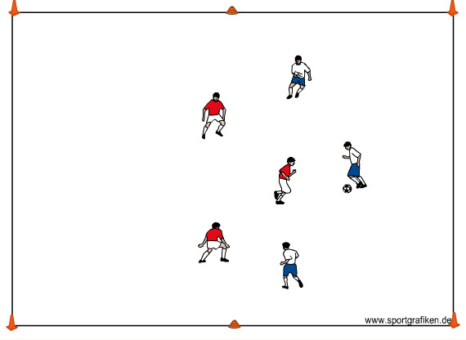
1) 3v3 to lines - - Create multiple fields that are 30yds x 20yds with 6 cones outlining the field (enough so all players are playing), break all of the players in to teams of 3. Each team will defend the end line behind them. Players have to dribble across the end line to score. Note: Play with offside (20 minutes)
Game can be played to two or three small goals on each end line.

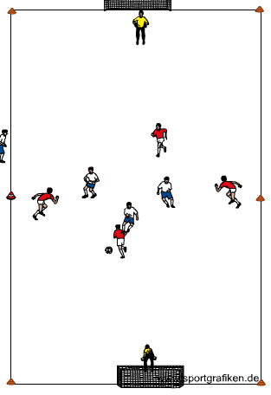

2) 4 v 4 (-1) + Goalkeepers - - Two teams are playing 4 v 4 to two goals on each end line and a goalkeeper in each goal. The attacking team is playing with four players, but the defending team must drop one player back behind their own end line while under attack. This prevents the defending team from playing man to man and must solve the problem with zonal play. When the defense wins the ball they must first play the ball back to their teammate on the end line while the other team removes a player from the field. Note: Play with offside (20 minutes):

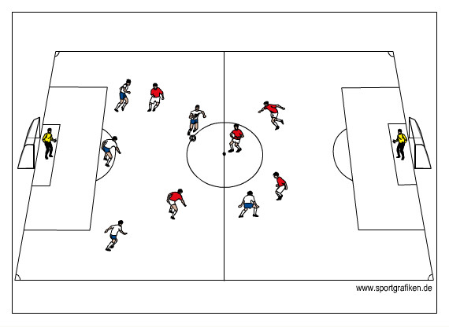
3) 6v6 to two big goals - - On a field 40 yards wide by 60 yards long with a goal at each end, create two teams of 6 (5 players and a GK). Play a regular game highlighting pressure, cover and balance. Version 2: If the players are scoring quickly, adjust so teams can only score if all of their team is in the attacking ½ of their field. This will allow the defending team time to get more organized and adjustments of the 1st, 2nd and 3rd defenders. (20 minutes)

4) 8v8 Game - - Depending upon numbers, space will change and numbers will change. Ideally, finish with the number you normally play with in games. Play a regular game with goalkeepers. (25 minutes)

U13 U14 Improving the Goalkeepers Distribution

Objectives -- To improve the goalkeeper’s ability and decision making in ball distribution by throwing it or by using his/her feet to pass the ball to a teammate or clear the ball out of danger during a game. This way, he/she can understand better their role in initiating the attack.

Coaching Points:
Hand Distributions -- Throws are usually much shorter than kicks, but much more accurate. A quick throw right to the feet of an open teammate is often the safest distribution. The goalkeeper has several basic throws available. I've listed them here in the order of decreasing accuracy and increasing distance.
- Roll Throw -- Control the ball between the palm of the hand and the forearm with a bent wrist, step with the opposite foot, and "bowl" the ball, making sure the fingertips touch the ground on the delivery. This will require bending the knees and waist to get low enough. Just like in real bowling, you don't want to drop the ball from the hand to the ground.
- Baseball Throw -- The ball starts in the palm beside the head and is thrown straight forward as the keeper steps into the throw. Some backspin on the ball will help it "sit down" and make it easier to receive, so the keeper can let the ball roll off the fingertips slightly at the end of the release to provide this. Make sure the fingers are slightly over the top of the ball to keep it on a level or downward trajectory.
- Overhand Throw -- The overhand throw or "sling" is the longest but least accurate throw. It can be a good technique for very young players, since sometimes they can actually throw it as far as they can punt it. The soccer ball is again controlled between the palm and forearm with a bent wrist. The arm is placed almost straight back, and as the keeper steps into the throw, the arm is fully extended, elbow locked, and brought around in a circle, over the head, and released towards the target. The hand should end pointing at the target, and letting the fingertips roll under the ball at the finish can provide some backspin to help the ball roll smoothly.
- Look up quickly after catching the ball (vision)
- Goalkeeper decides quickly where to throw or kick the ball (transition)
- Concentrate on accurate distribution
- Communicate with Teammates

Dealing with Back Passes -- The Goalkeeper can receive the ball using one or two touches to switch the point of attack, connect with other players or clear the ball in case of high pressure.
- The keeper who is making himself/herself available must move away from the goal and outside the near post. This puts him/her in the least vulnerable position should the pass go awry. The Goalkeeper should communicate with the player – “Drop” or “Back”
- He/she should be in line with the ball to receive it or clear it
- Make a quality first touch to take the ball out of pressure ( 1st. Touch control the ball, 2nd Touch pass) Clear or switch the point of attack
- If under pressure, clear the ball out and wide
- It is recommendable the keepers control and pass with both feet
- The keeper has three options: (1) pass ball to a teammate; (2) play a long ball over the top; or (3) clear the ball to the safety of the touchline

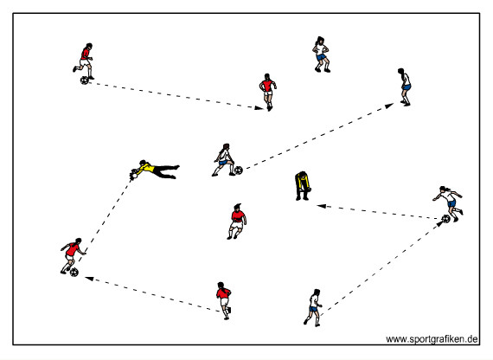
1) Goalkeeper Technical Box - - Divide the field players into two groups (a red group and a blue group). Each group has 1-2 soccer balls. Position the two groups with the goalkeepers on half of the field passing and moving freely throughout the space. Field players must pass to any goalkeeper when the opportunity arises. The goalkeepers must use their feet during this phase. Gk must use two touches to release the pass.

Version 2: All balls played to keepers must be on the ground; keepers field the ball with their hands, then they distribute to any field player by rolling and/or bowling the ball to the players.

Version 3: Balls must be played over distance in the air to the keeper; keepers catch the ball with their hands, then they distribute to any field player by using any of the three throws. (20 minutes)

Note: During this section of the practice, help the GK with the technique of the various throws and give tips on when and how to use them. This way he or she can later make the decisions for themselves.

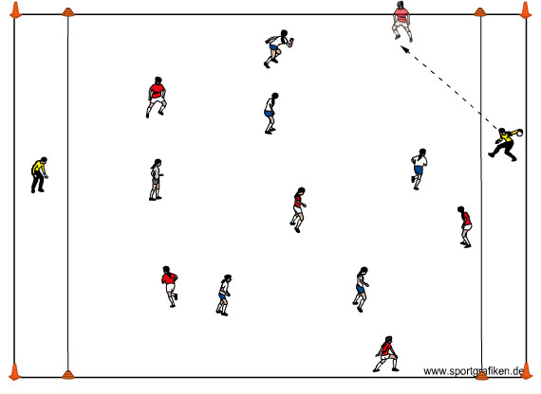
2) 5v5 or 6v6 + Target Goalkeepers - - Divide the players in two teams to play 5v5 or 6v6, each team has a goalkeeper in a 5 yard end-zone. Teams score 1 point when they hit the GK. The GK must restart the game by distributing the ball with his hands as soon as possible. When the defending team regains possession of the ball, it must be passed to GK to commence the attack by playing with his/her feet. (20 minutes)

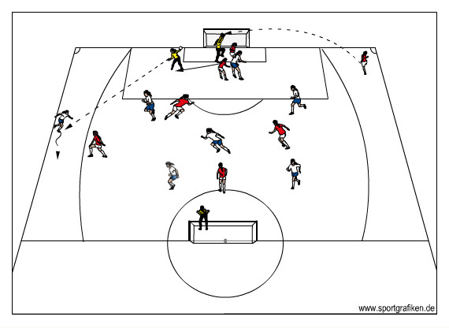

3) 5v5 + GK’s and Crossing Channels - - Game incorporates a crossing channel in which players can get in there, receive the ball either by goalkeeper distribution or by a teammate’s pass and cross the ball inside the box to score. The goalkeeper will come out, get the cross and distribute the ball as soon as possible to any player available, preferably inside the channel, but not necessarily. This is a goalkeeper decision. The distribution should be opposite of the cross. The Gk must make the decision of what type of throw he/she will use by surveying the field as quickly as possible. Any player can enter flank channels. Coach must ask the team in possession to spread out as soon as possible to provide the Gk with a possible target. (20 minutes)

4) Play a game With no restrictions. During this game reinforce the coaching points above and help the Gk to recognize the distribution possibilities that the game may give him/her in order to become a more effective attacking team. (20 minutes)

5) Cool-down -- Individual juggling with restrictions: feet only, feet and thigh only, 3 small juggles then 1 big touch above head, unrestricted. Players will perform static stretching of the major muscle groups. (10 minutes)

U13 U14 Combination Play
Objectives: To help players to recognize combination play with two to three players, as well as movement off the ball from the 3rd and 4th players.

Coaching Points:
- Intelligent movement off the ball
- Head up, preparing body to receive the ball (ball across body to see all options)
- Surveying the area, looking for target early, anticipation
- Passing accuracy and pace
- Keeping appropriate individual and group shape
- Playing in the direction you are facing
- Looking for timing of runs into receive ball from neutral players
- Communication (asking for ball)
- Inside player receiving ball across body to see all options if possible
- Players reading each other to see who is making the run in to get ball
- Movement of the other two players off the ball
Wall pass:
- First attacker runs right at the defender with the ball
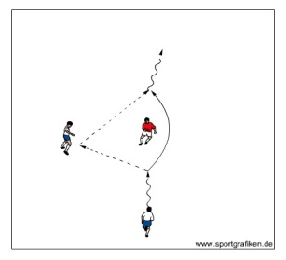
- The second attacker sets up level with or slightly ahead of the defender, turned sideways, shoulders pointed to the goals
- When the first attacker is close to-but still out of tackling range of-the defender, he/she must read cues from the defender
- If the defender is attending more to the first attacker, then the first attacker should pass the ball to the wall player’s (2nd attacker) front foot
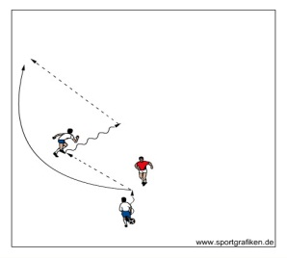
- The 2nd attacker plays the ball with one touch into the space behind the defender and into the running path of the first attacker
- The 1st attacker sprints to receive the ball preferably in the natural flow of her run.
Two players Overlap:
- The first attacker plays the ball to the second attacker who dribbles in a direction away from the overlapping space
- The second attacker dribbles to create overlapping space and the first attacker then becomes the player who overlaps. The ball is played into the running path of the first attacker
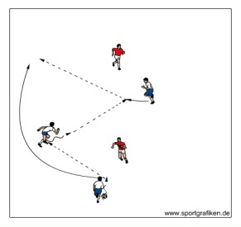
Three players Overlap:
- The first attacker plays the ball to the second attacker who dribbles in a direction away from the overlapping space
- The second attacker dribbles to create overlapping space and Connects with a third attacker who receives the ball and plays it into the running path of the first attacker who had made the overlap run

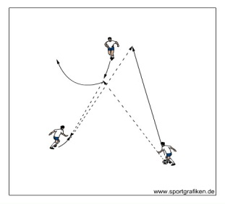
Up-Back-Through:
- A central forward, with back to goal, checks on a slight angle toward the center midfielder.
- The center midfielder passes to the forward; the forward one touches the ball back to the center midfielder; the center midfielder plays a one touch through ball into the space created by the central forward to a third player

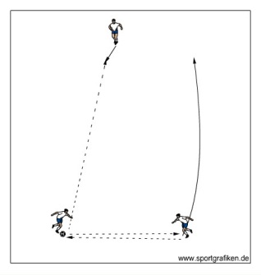
1) Short-short-long
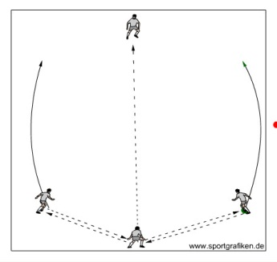
Players pass the ball within their group. Two of the players position themselves about 5-10 yards apart and pass the ball back and forth to each other (short passes), while the third player (long player) drifts about 20-25 yards away. After 4-5 short passes, the long player calls for the ball. The ball is played into the long player. The player that played the ball into the long player stays home, while the other player joins the long player. They begin to (short) pass to each other until the new “long” player calls for the ball. The activity continues in this manner for 2-3 minutes to develop a smooth rhythm in the passing sequence. Players consistently keep themselves and the ball moving. (Develop a triangle shape) (10 minutes)

Groups of 4: Same setup as above, but three players make short passes to each other, while one player is away. When the ball is played long, the passer stays home and the other two players join the “long” player. (Develop a ‘kite’ type shape) (10 minutes)

2) 3v3 plus 4 Neutrals
In a grid 35yds x 25yds, three players are in Red and three players are in Blue inside of the grid, with the four neutral players positioned on the four sides (free movement up and down the sidelines). Red team tries to keep possession and can use neutral players on the outside. To get points, the team in possession must find neutral players on outside and neutral player must find that player back or another one on the same team to get a point. First team to 10 points wins. Blue does the same when they have possession of the ball.
Version 2: Neutral player tries to play it back to another player on the team (besides the one who passed it to them) to get a point. Neutral player on outside should not force the ball into a third player, important to keep possession, so can play it back to the person who passed it to them (they just do not get a point, but do maintain possession). Note: Must find one Target player to get a point, then to get the next point, must find another target player (20 minutes)

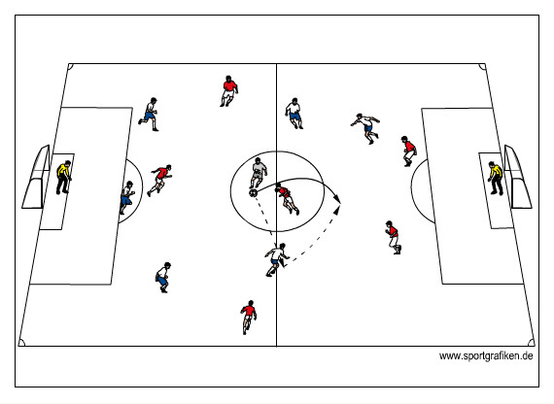
3) 5v5 plus Neutral to Goals with Goalkeepers
In a field approximately 60 yards long by 50 yards wide play 7v7 to big goals, with goalkeepers, and position one neutral player on the field. Play a regular game…the one neutral player always plays with the attacking team (team in possession of the ball). This activity will stimulate combination play and movement off the ball. (20 minutes)

4)7v7 / 8v8 Scrimmage
Depending upon numbers, space will change and numbers may change. Ideally, finish with the number you normally play with in games. Play a regular game with goalkeepers. (25 minutes)

5) Cool-down (5 minutes)
Groups of 3: One player is the server and has the ball in their hands and the other two are ready to juggle. Server says 2 and 2 which means the server tosses the ball to the first player who has to juggle the ball two times before getting it to the next player who has to juggle the ball twice and get it back to the server (ball should not touch the ground). Server can change numbers of juggles to 1 and 1, 1 and 5, 3 and 4, 4 and 2, etc.

Lesson Plans and Activities 9th through 12th Graders U15 U18

U15 –U18
Passing With Purpose
Passing needs to be a means to an end. It is all well and good to possess the ball but players should be constantly looking to pass the ball forward. Possession to unbalance defenders to one side of the field in a slower tempo followed by a change of speed of both player’s on the ball, and those making runs away from it are key to success. Recognizing moments to play one touch soccer between two, three or four players is both difficult to defend against and very productive.
Player’s must be able to have multiple repetitions in practicing the technical aspects of dribbling, passing and receiving in an environment that promotes success. As player’s become comfortable with the ball, we need to place increasing amounts of pressure on them to help them learn to keep possession in game-like situations. Simple decision making of what space to attack, where to move to in order to be an option for a teammate, what shape their team should maintain, and anticipating the play are decisions the players need to begin to make quicker as their knowledge of the game increases. In order to provide more success, neutral players or bumpers can always be added in order for the attacking team to have an advantage in numbers. This will increase the players’ confidence in maintaining possession within small groups. Movement and support play by players away from the ball in a pro-active, rather than re-active manner is essential to success.

Moving into a directional game changes the demands on the players. Therefore, it is critical not to think that teaching possession in a 360 degree game is sufficient to prepare our team for the game. Directionality forces players to anticipate the play even more, and adjust their shape in order to maintain possession and ultimately go to goal. In addition, it forces players to be more specific with the location of their passes and direction of their first touches. Players will now need to think about how to penetrate the opposing team in order to go to goal, instead of being equally rewarded by going backwards (as a 360 degree game promotes). Replicating the true game of soccer will allow the players to improve their ability to give appropriate supporting angles, put the proper weight on the ball, communicate with their teammates, and receive the ball under pressure, among other aspects of the game on a higher level.

Technical Skills

Passing Coaching Points
- Ankle locked and get body behind the ball
- Non-kicking foot is placed parallel to the ball
- Toe of the non-kicking foot pointing towards your target
- Be on your toes and balanced
- Go to the ball, do not wait for it
- Toe up, heel down (inside) or toe down & turned in (outside)
- Eyes on ball at instant of contact
- Follow through to partner
- Strike ball solid through the middle
- Knees slightly bent, non-kicking foot pointed to target and parallel to ball
- Pay attention to proper weight and timing

Receiving on the Ground Coaching Points
- Get your body behind the ball
- Be on your toes and go to the ball, do not wait for it
- Keep ankle of receiving foot locked
- Toe up, heel down (inside) or toe down & turned in (outside)
- Cushion ball as it arrives (as you would catching an egg)
- Point of contact is the middle of the ball
- Do not deaden the ball
- Make your first touch active by pushing the ball in the direction in which you want to go(typically away from pressure)
- Practice with both feet
- Get head up before and after receiving
- When receiving balls with back to goal or in midfield, try to receive sideways on (with body sideways to the length of the field) and look over shoulder before receiving the ball
- Always try to receive the ball facing the way you want to play.

Passing With Purpose

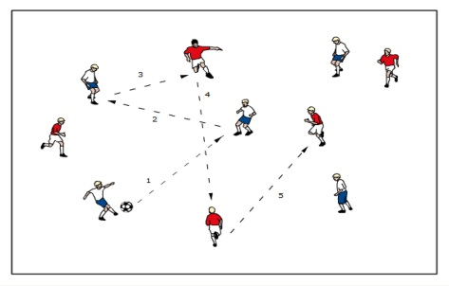
- Colors-Warm Up (Warm up)---Half of the players in red pennies, half in blue. Teams playing together in the same space combine in the passing sequence blue-blue-red-red-blue-blue-red-red etc. etc. Ball can never stop, players can never stop moving, and ball cannot leave area of play. Coach can limit touch-count, mandate which foot to pass with or which side of foot to pass with as sees fit. When players can do first sequence adequately and without frequent errors change the sequence to blue-blue-blue-red-red-red-blue-blue-blue etc. etc. Stress communication and technical passing points throughout. Make this activity competitive by counting errors and setting goals by lowering allowed errors. (15 minutes)

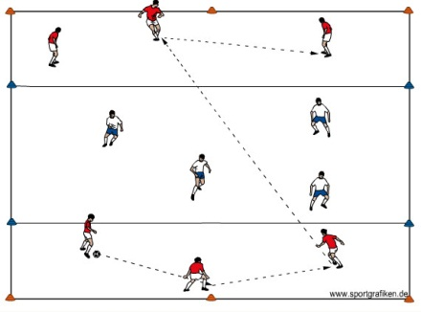
- 3 v [4] v 3 (Small Sided Activity) --- 3 players are placed in an end zone across both long ends of the playing area. 4 players are in the center of the area trying to prevent passes reaching the three players behind them. They cannot enter the end zone. The 3 players are encouraged to create a rhythm of play looking for opportunities to “split” or “bypass” the defenders with a pass to the opposite end zone. To add pressure one defender may enter the end zone. Increase or decrease numbers dependant on success.
Varyation: One of the end line players can also check into the center zone to receive and play forward. Add numbers 4 in end zones.
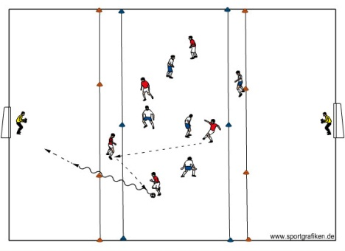
- 4v4 plus Targets to Big Goals
Big goals are placed behind the target players at each end. Players must play through the target player before releasing a player into the space behind the target to finish. Player breaking free is initially unchallenged then a defender may chase. Also a defender can be placed behind the target and in front of the keeper. This challenges players to time their runs into the space behind the target

- 6v6 to 8v8 regular game (Game)---If playing 6v6 with goalkeepers, the field size should
be approximately 45 X 60 yards. It playing 8v8 with goalkeepers, the field should be
approximately 55 X 80 yards. (25-30 minutes)

U15-U18 Functional Training of the Central Defenders

Objectives: To help improve the decisions of the central defenders in terms of how they defend, where they defend and what they do when they win possession of the ball.
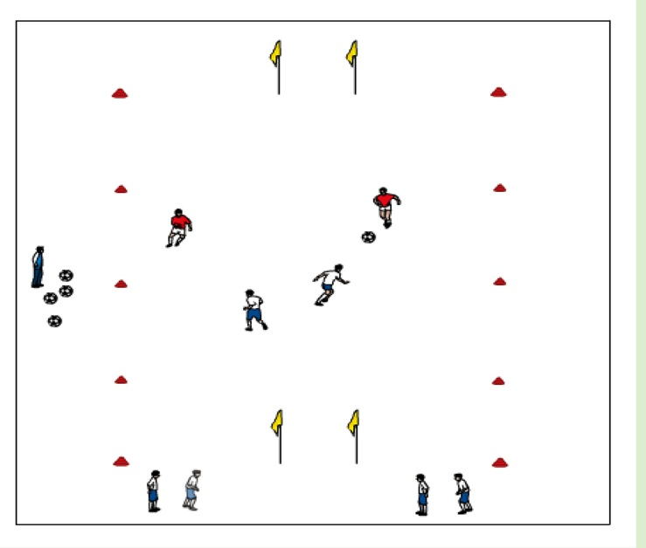
1) 2v2 to small goals (Warm-up – 20-25 minutes): Set up many small sided fields 20 yards long by 15 yards wide. Organize many 2v2 games. Set up teams by function: 2 central backs play together as a team, 2 center mid’s play together, 2 center forwards play together, outside backs play together, etc. At the field where the central backs are playing, have an extra team or two on the outside. Rotate these teams into the game to play against the central backs. Coach serves balls into the field from the outside and at the mid point of this field. They will play the ball in to the team playing against the central backs.

Coaching Points:
- Communication – who should be pressuring ball, which way to force the player with the ball, when to step and put tighter pressure on them (especially in relation to the defensive
1/3 of the field).
- Cues for central backs: Bad touch on the attackers part – aggressive to win the ball, distance of 2nd attacker in relation to goal determines if 2nd defender (central back) can step and double team 1st attacker (if 2nd attacker takes themselves out of the play) or must be dropped off just slightly and about a 30 degree angle.
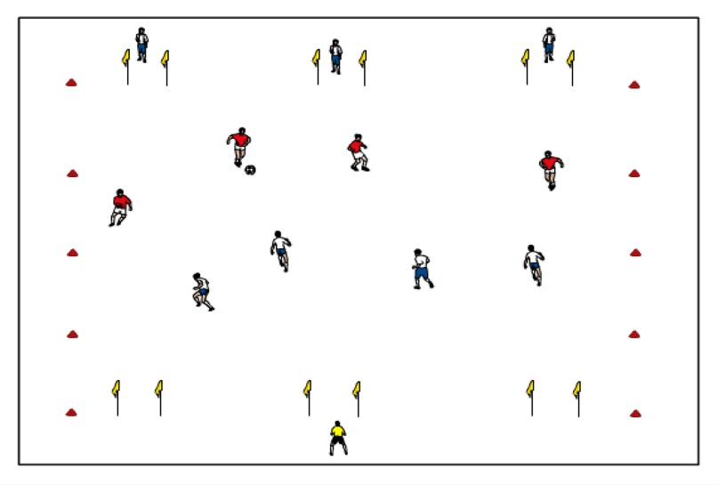
- Central Backs have many technical functions that should be considered: heading; ability to clear the ball with feet and head; tackling; quality first touch; immediate transition with the dribble, pass or shot.

2) 4v4 to six goals (20 minutes): In a field 35 yards long by 50 yards wide (wider than longer), place three goals on each end line (central, left and right). Have 4 backs play against 2 forwards and 2 midfielders. Coach can add in another player or two for each side as play continues. Use of extra players: the GK can play behind the goals that the 4 backs are defending to aid in communication. Add in 3 target players behind the goals that the 4 backs are attacking.

Coaching Points:
- Reinforce coaching points from activity #1
- There must be pressure on the ball! Cues: as ball is traveling, defensive shape (pressure, cover & balance, flatness) must take place!
- Central Backs need to organize the back four as a group defensively through communication – when to step, when to shift, when to drop, etc.
- Decide marking responsibilities and zonal coverage on and off the ball.
- Transition…when they win the ball back, do they have a plan to go forward as quickly and efficiently as possible or can they keep possession until the opportunity to go forward is ON!

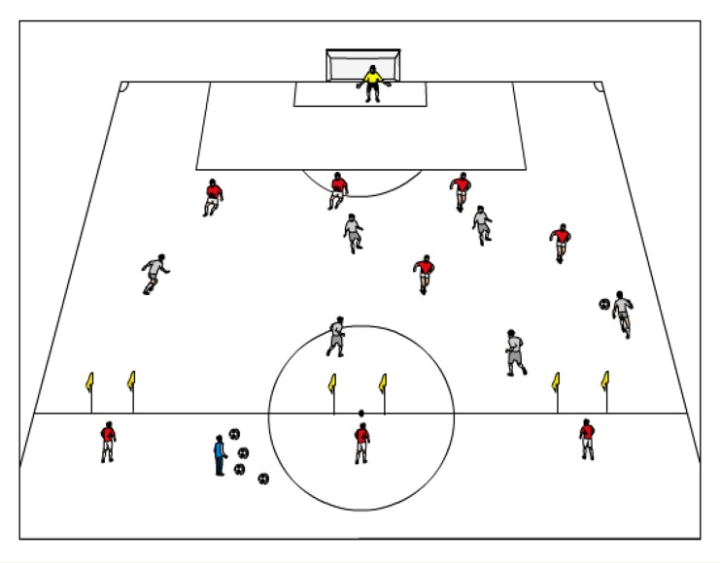
3) 6v5 plus GK to 1 big goal and three small counter goals (20 minutes): Use ½ the field for this game and place three small goals (can also place targets behind each goal to get more players involved), left, center and right on the midfield line. Team of 6 will attack the big goal and the team of 5 (plus a GK) will attack the 3 small goals.

Coaching Points:
- Reinforce defensive coaching points from activity #1 and activity #2.
- Central Backs must read that when the ball is being played out (either by themselves, their GK or the outside backs, they must communicate to get their whole defensive line to step up the field and quickly.
- GK must stay connected with the back four and the rest of the team.

4) 8v8/11v11 scrimmage (30-45 minutes): Depending upon numbers, space will change. Ideally, finish with the number you normally play with in games. Play a regular game with goalkeepers. Be sure to finish with 4 backs for either number to ensure continuation of understanding of roles for the central backs.

Coaching Points:
- Reinforce coaching points from activity #1, #2 and #3
- Reinforce positive decision making opportunities (recognizing when to step defensive line up, how to maintain possession if they win it, when to get players (outside backs/selves/midfielders)
to pressure ball, etc.)

U15-U18 Functional Training of the Central Midfield Players

Objective: To provide a training environment that focuses on the functions of the central midfielders: where they play, how they play and the decisions they make to keep the attacking action connected, effective and going to GOAL.

1) Inter-passing in Two Groups with Designated Central Midfielders (25 minutes):
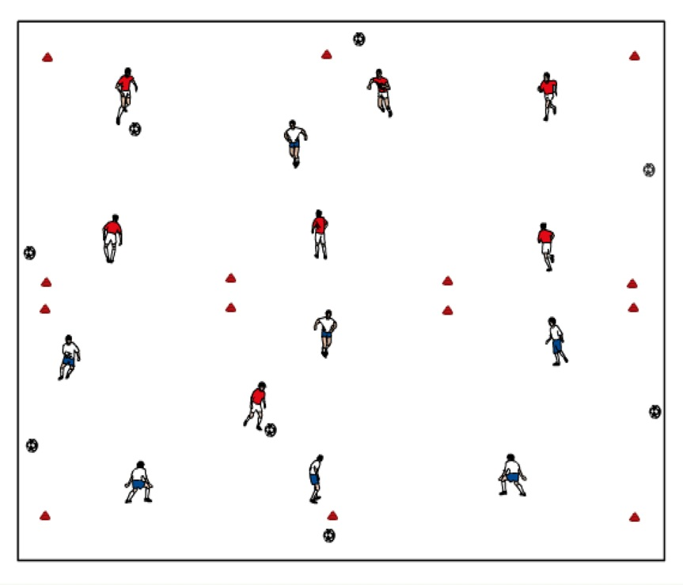
In two grids, each 30 yards long x 20 yards wide, two groups of 7-8 players inter-pass the ball freely. Dress your central midfielders (CM’s) in a different colored vest and assign each one to a different grid. As the ball is being passed amongst the players in the grid, the CM must demand the ball every 3-5 passes and play it back to the player who passed it to him or play it to another player in the grid. Version 2: If the CM plays the ball back to the passer, it must be one-touched. If he plays it to another player, he can take 2-3 touches before passing it.
Version 3: Introduce an opponent who is responsible for marking the CM
man-to-man.
Version 4: Play an 8v4 keep-away game. Make sure that your CM is one of the Eight. The Team of Eight is awarded a point every time they can pass to the CM and the CM can return it to one of the Eight. The team of four is awarded a point if they win possession and can dribble the ball out or pass it out of the grid to a teammate.

Coaching points:
- CM must be technically clean…perfect execution (dribbling, receiving, passing, shooting, heading, tackling)! CM must be technically fast…timing of dribbling and/or passing is crucial!
- CM must be tactically fast…timing of decisions to speed up play or slow it
down is crucial!
- CM must be tactically fast…patience…keeping space live…knowing when to
show up for the ball.
- CM must be surveying the field 100% of the time to give proper direction to his teammates…keep the ball; slow it down; change the point of attack; penetrate,
delay the opponent’s attack, win the ball back, etc.
- CM must know when to move the ball to another part of the field.

2) 4v4 game to Six Goals with Target Players (25 minutes):
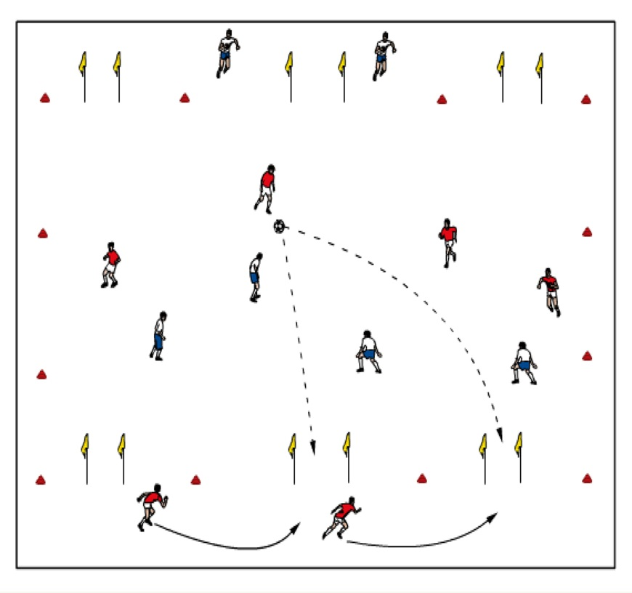
In the middle third of the field set up a grid the full width of the field (about 60 yards) and 35 yards long (the grid is wider than it is long). On each 60 yard end line set up three 4-yard goals with cones or flags; two of them about 3 yards in from each corner and one centrally located. Make sure that one of your CM’s is assigned to each team of four. Position 2 target players behind each set of goals on both ends of the field. Play a game of 4v4. Each team scores by passing the ball through one of the 3 goals opposite them to a target player. The 2 target players must move laterally, covering all 3 goals, and show up behind a goal at the right time to receive a ball from the attacking team. If a goal is scored, the target player who received the ball restarts the game by passing it in to the team who just got scored upon.

Coaching Points:
- Reinforce the coaching points from the 1st activity.
- Pay special attention to the decisions made by the CM:
- is her combination play appropriate;
- is she looking to penetrate into the attacking third when possible;
- if she’s defending, is she forcing the ball into appropriate pockets of the field;
- is she taking responsibility for the ball and taking long range shots, getting the ball to flank players to open up the opponent’s defense, and/or slotting passes through the defense to forward players.

3) Match…8v8 to 11v11 (30 minutes): Organize your players into 2 teams and play soccer.

Coaching Points:
- Reinforce coaching points made throughout the training session.
- The coaching points made in these more realistic game-like environments will be more beneficial to the players.

U15-U18 Functional Training of Wide [Wingers] Midfield Players

Objectives: To help improve wing midfield play in the attack.

1) 4 v 4 + 2 Outside Players (Warm-up – 20-25 minutes):
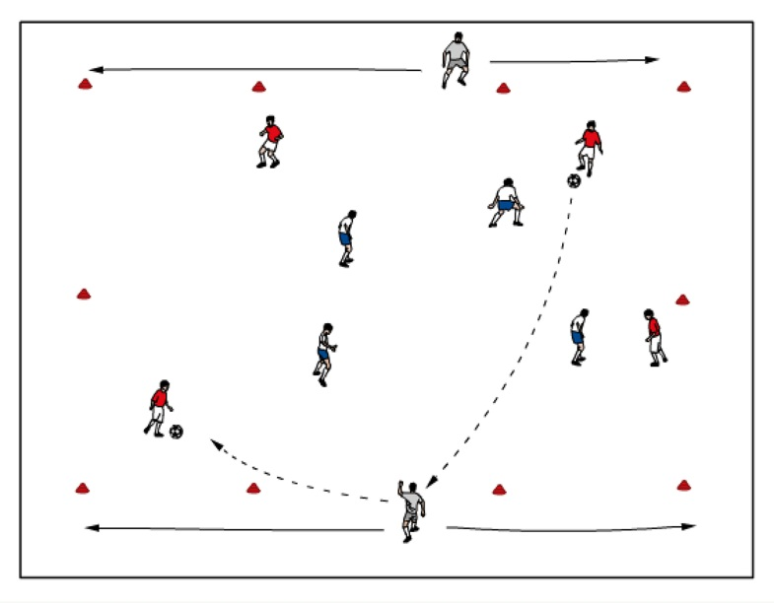
Version 1: Two teams of four players play in a grid approximately 25x40 yards. Outside players are positioned on the longer sides of the field and are available to the team that is in possession. Version 2: Outside players must play the ball to a player other than the one they received it from.

Coaching points:
- Encourage the outside players to be active up and down the sideline.
- Remind outside players to look around before they receive the ball!
- Change outside players every 2-3 minutes.
- Eventually try “two touch” restriction on all players.

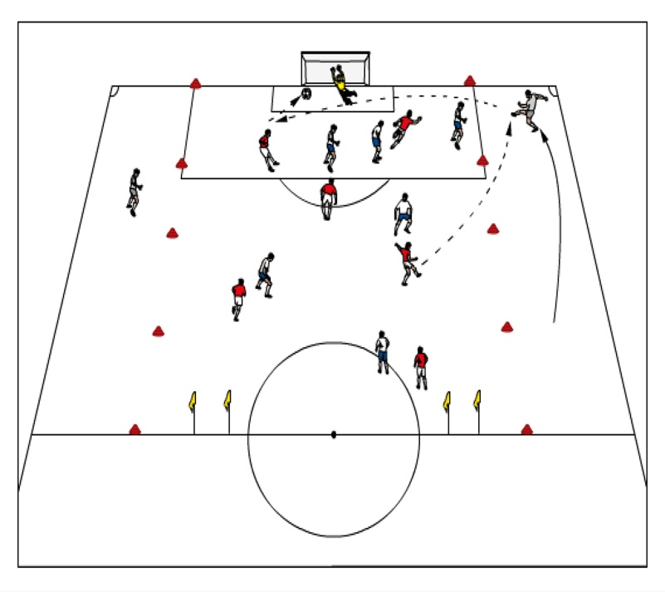
2) 7 v 6 +2 Outside Players (25-30 minutes):
One team plays with a goalkeeper and 6 field players and attempts to score on two small goals. The other team plays with 6 field players and attempts to score on a regulation goal. Field is 45x 60 yards. Each team can use the outside players when in possession. O goal resulting from a direct assist from an outside player counts as two points.

Coaching Points:
- Encourage wide players to be very active up and down the sidelines.
- Remind wide players that they must demand the ball – communicate!
- Wide players should look for quick combinations on the ground as well as crossing balls to change the point of attack.
- Wide players must use the time without the ball to decide what they will do when the ball comes to them – think one step ahead!

3) 9v9 or11v11 scrimmage (30-45 minutes): Depending upon numbers, space will change. Ideally, finish with the number you normally play with in games. Play a regular game with goalkeepers.

Coaching Points:
- Reinforce coaching points made throughout session.
- Goals resulting from crosses from any wide players count as two points.

U15-U18 Functional Training of Outside Defenders
Objective: To help improve outside defenders play in the attack.

1) 6v0 Shadow Play with Goalkeeper (Warm-up – 10-15 minutes): Begin by having the four backs and two midfielders passing the ball around freely, without pressure, in the defensive third of the field. On the coach’s command, wing backs are to find central midfielder, center back or the coach.

Coaching Points:
- Wing backs must receive the ball with their hips open to the field, so that they can see the entire field ahead of them.
- Proper technique of receiving and passing whether the ball is in the air or on the ground.
- Proper angle of support to receive the ball from center back or midfielders.
- Good first touch forward, into space when available.
- Eye contact must be made when passes are made.

2) 6v3 to Counter Goals with Goalkeeper (15-20 minutes):
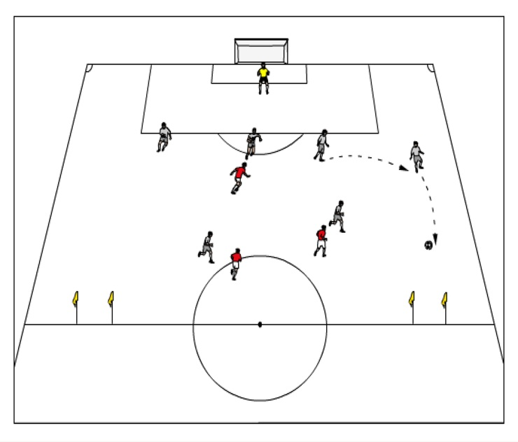
In the defensive third of the field, four backs are trying to combine with the two midfielders to score on the counter goals at midfield. Two forwards and one midfielder apply pressure and attack the full size goal when they win the ball.

Coaching Points:

- Wing backs need to recognize when they can play forward and when to retain possession.
- If wing backs have open midfielder or space to play ball forward to goals, they must do so (no pressure).
- If wing backs see defender taking the goals they must find midfielders or backs to retain possession.
- Wing backs may dribble penetrate if space and pressure is not applied in the defensive third.
- Reinforce points mentioned in warm-up.

3) 8v6 to Counter Goals with Goalkeeper (20-25 minutes):Build to playing with four backs three midfielders and one forward to counter goals against two forwards and three midfielders and one defender scoring on the full size goal.

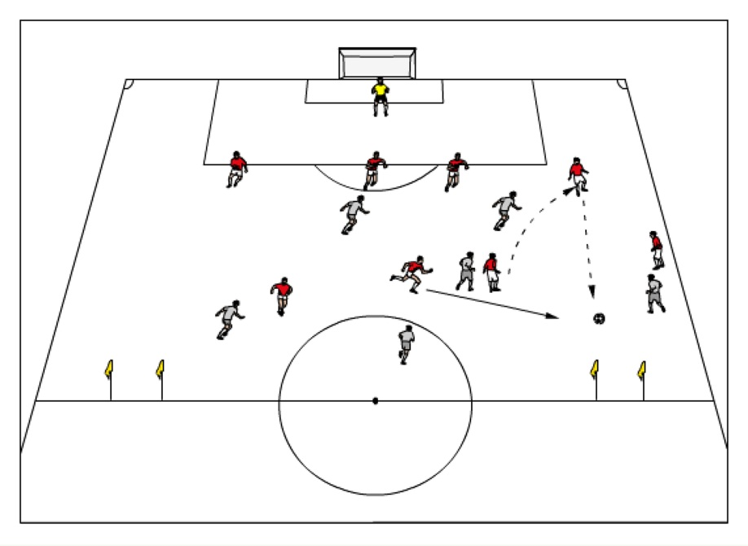
Coaching Points:
- Wing backs should look to pass to the forward when possible, recognizing where pressure is coming from and if the forward is available to receive the ball.
- When under pressure from the forward from the inside of the field, wing backs need to recognize if they can either pass to the forward or to an outside midfielder in order to build the attack.
- Wing backs can look to overlap when outside midfielder dribbles the ball towards the middle of the field and space is open on the outside of the field, creating a 2v1 situation.
- Reinforce points made previously.

4) 9v9 Scrimmage to Two Goals with Goalkeepers (25-30 minutes): Using a 4-3-1 v a 3-3-2 formation, play a match to two goals. Move the goals up 12 yards from the goal line on each end and use the full width of the field. Moving to 11v11 if your team has the numbers is advised as well.

Coaching Points:
- Reinforce coaching points made throughout session.

5) Cool-down (10 minutes):
In groups of four, choose one “captain” per group who will lead them on a slow jog in different directions around the field. During the jog they are to perform various dynamic stretches while cooling-down. Finish with static stretching of major muscle groups.

U15-U18 Functional Training of Two Central Strikers
Objective: To help the forwards recognize movement off each other and in relation to the defenders to combine and get through the defense, to create space for self and others, as well as recognizing cues of getting the ball from the midfielders/backs.

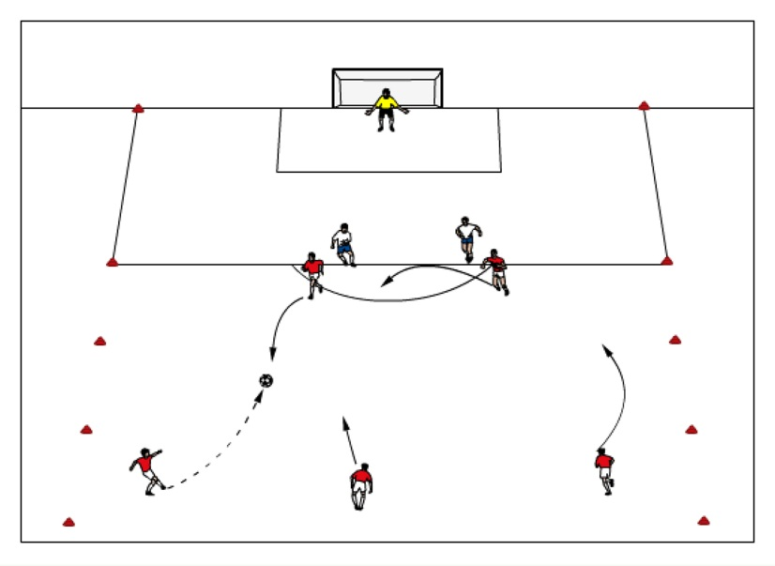
1) Functional Pattern Play (30 minutes):
5 v 2 + GK: three midfielders and two forwards versus one goalkeeper. The 3 midfielders pass 5-7 times between each other about 40-50 yards out from the end line. The two forwards look to receive the ball from the midfielders, combine with each other or with the midfielders and finish on goal. (The forwards must receive the ball
18-25 yards out from the goal before going to goal).

Possible patterns:
- As the ball is played to the left midfielder, the left forward makes an early checking run toward the ball and spins out creating live space for the right forward to check into to receive the pass at the appropriate time. The forward can: turn and shoot on goal; combine with the other forward who has recycled his run and finish with a shot; play the ball to the central midfielder who can take a long range shot, etc.
- The central midfielder can play the ball to the right forward who passes it to the overlapping right midfielder; the right midfielder then serves a ball to the left forward making a well timed run to the far post.
- Any one of the midfielders plays a ball to the high forward, who plays it back to the other forward, positioned at a slight angle, who shoots on goal.

Version 2: Add in one defender against the two forwards. Version 3: Add in two defenders against the two forwards; now when a midfielder plays the ball into one of the forwards, any one of the three midfielders can join in the attack. Version 4: Add in a third defender against the two forwards and now when the midfielder plays the ball into one of the forwards, two of the three midfielders can join in the attack. Version 5: Add in 1-2 defenders against the midfielders and now let all midfielders combine when the ball is played into the forward.

Coaching Points:
- Combination play
- Cue of passer to forward – looking up – make eye contact and/or verbal communication.
- Forwards’ ability to create space for themselves and others – timing of runs to either get the ball themselves (recognizing passer’s cues) or get in and behind the defense – angles of runs.
- Quick 1-2 touch combinations (wall pass/take over/overlap/double pass).
- Intelligent runs by the forwards – diagonal / straight / bent around defender to get ball back.
- Appropriate supporting angles – looking to read the defenders – do they both commit to the forward with the ball, where is the space that just opened up – should the other forward look to make a run in behind defenders or drop off behind the forward with the ball to use as support, etc.
- Forwards should look to work ‘off’ each other; angled positioning of the forwards within playing distance of each other.
- As the ball is played from side to side the two forwards may switch roles, but must stay connected.

2) Three Zone 8v8 plus GK’s to 2 Big Goals (30 minutes):
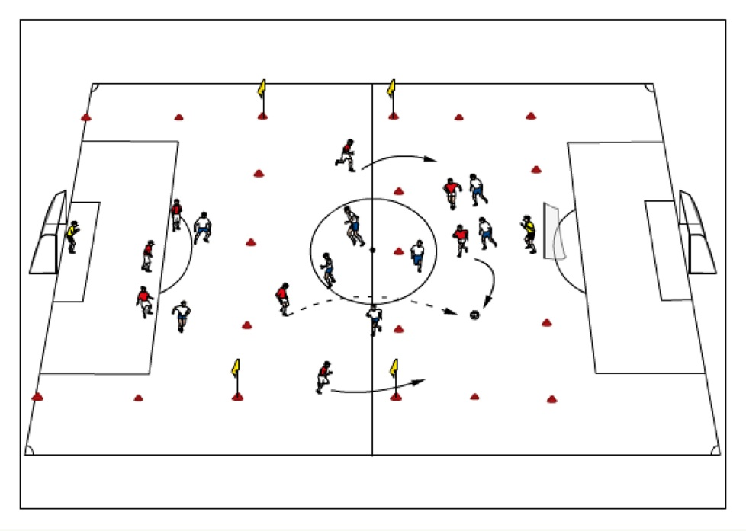
In a field 60 yards wide by 80 yards long, 2 teams of 8 plus goalkeepers. Field is split up into three zones (25 yards long on both attacking zones and 25-30 yards long in the middle zone. If goalkeeper plays it to their backs, backs can look to find midfield players or attacking players. Version 2: Once a pass is made into attacking third, any midfielder from attacking may join in to create a 3 v. 3 in the attacking zone.
Version 3: Two midfielders may join into the attacking third to create a
4 v. 3.

Coaching Points:
- Reinforce coaching points from Activity #1

3) 9v9 /11v11 scrimmage (30 minutes):Depending upon numbers, space will change. Ideally, finish with the number you normally play with in games. Play a regular game with goalkeepers.

Coaching Points:
- Reinforce positive decision making opportunities (recognizing opportunities of when forwards should check to the ball, what type of run, movement of other forward off the ball – combine/support/get self in for shot, etc.).

4) Cool-down (10 minutes): Groups of 5 heading challenge. One player in the middle, four players circle around them. Player in the middle tosses ball to player on the outside who heads in back to player in the middle. Player in the middle then heads to next player on the outside, who then heads it back to player in the middle and so on. Give player in the middle multiple chances to get the ball all the way around the circle - switch up players to ensure everyone gets a chance to be the middle player. Finish cool-down with static stretching of major muscle groups.

U15-U18 Functional Training of Three Forwards
Objectives: To help improve play of three forwards in the attack.

- 3v3 to end lines (Warm-up – 10-15 minutes):
In a 20x30 yard space at the top of the 18 yard box (in the attacking third of the field), play 3v3. Team defends one end line and attacks the opposite end line. Goals are scored when one team dribbles the ball past the opposite end line while keeping the ball under control.

Coaching Points:
- Players should be looking to penetrate via dribbling and through passes
- Creating depth and width when in possession of the ball
- Attackers should provide support for the player with the ball

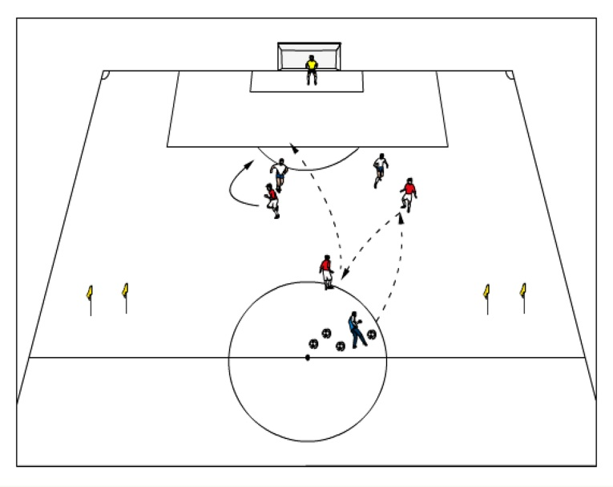
2) 3v2 with goalkeeper, building to 5v4 with goalkeeper (20-25 minutes):
Start off with pattern play and movement of three forwards using the various patterns listed below. Three forwards score on goal while defenders can score through the counter goals or by passing to the coach. Use the top of the penalty box as an offside line. Add two wide mid fielders on the attacking team (red) and two outside backs on the defending team (white).

Possible patterns:

1. Ball is played to one forward who lays the ball off to the withdrawn attacker. When pass is laid off, third forward peels off and bends run behind central defender to receive through ball played by withdrawn forward.
2. Ball is played into right forward from outside angle who steps over the ball and turns toward goal. Left forward plays on touch pass between the center backs to right forward who runs onto the ball for a shot or cross.
3. Ball is played into left forward who lays ball off for withdrawn forward to have a shot on
goal.
Other forwards attack the goal for any rebounds.

Coaching Points:
- Two forwards need to provide as much depth (without being offsides) as possible.
- As ball is played, they need to check towards the ball in order to receive or play quickly to teammate.
- Proper technique when receiving, passing and shooting the ball
- Bent runs toward the goal to follow up for rebounds (frame the goal), front post, back post and middle runs must be made.
- Forwards need to make eye contact with passer of the ball to ensure timing of pass.
- Proper finishing technique- use large surface to redirect ball on goal.

3) 7v5 with goalkeeper (25-30 minutes): Red team attacks the full size goal with goalkeeper while the white team attacks the counter goals. Focus on the possible patterns listed below. Red team plays with three forwards (one withdrawn striker) and four midfielders while white have four backs with one defensive midfielder. Place cones 20 yards from goal for an offside line.
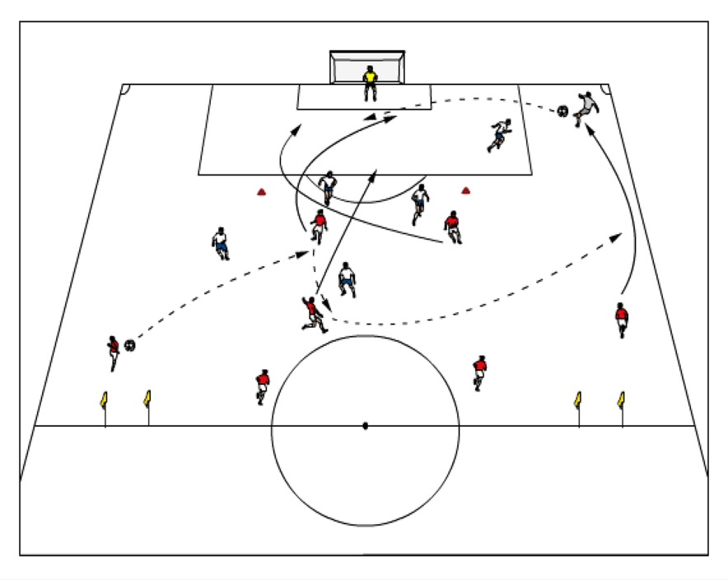
Possible patterns:
- Wide midfielder passes the ball into the first forward who lays the ball off to the withdrawn striker. Ball is switched to the other wide midfielder for a cross into the box.
- Central midfielder plays the ball into forward who directly passes down the wide channel to the outside midfielder for a cross into the box.
- Wide midfielder plays a wall pass with the forward in the wide channel and crosses the ball into the box.

Coaching Points:
- Reinforce coaching points made throughout session.

4) 11v11 scrimmage (30-45 minutes):
Depending upon numbers, space will change. Can play 9v9 with goals 12 yards from the end line. Ideally, finish with the number you normally play with in games. Play a regular game with goalkeepers.

Cool-down (10 minutes):

Summary
I hope you find the information contained in this manual helpful and that it not only provides you with some ideas on how to present the game to the players, but also that you found it educational.
Should you have any questions please do not hesitate to contact me at
glenbuckleysoccer.com
gbuc200398@aol.com or glen@glenbuckleysoccer.com
Thank you and remember, Have FUN!

glen buckley soccer llc

Glen Buckley BIO
If you are serious about soccer then as a player, coach, administrator and parent you need to expose yourself to quality information and instruction. Glen Buckley has grown up around the game and made it his life. He has amassed close to 30 years of experience in the coach education and player development arenas.
His early days were spent in his native England learning his trade working for his home town club Wigan Athletic as Youth Team and Center of Excellence Director. He has worked for The English Football Association, and Lancashire Football Association. When his playing career was over he focused his attention and devoted his adult life to further education. He gained his FA “Full Badge” at just 27 years of age. He was selected as one of the first 30 coaches in England to be a Tutor Assessor of the FA, shortly afterward completing his UEFA A license. Following successful stints as a manager in the Semi Pro leagues and scouting for numerous professional clubs he arrived on these shores in 1994 to take up a role as a Club Director of Coaching in Minneapolis, MN. Following 5 years in that role he was appointed State Director of Coaching for the New York State West Youth Soccer Association, a position he held for 10 years transforming the state coach education program into one of the most successful in the country. During this period he successfully acquired the USSF A, B, National Youth License and the NSCAA premiere diploma.
He currently serves as both a US Soccer and US Youth Soccer National Staff Instructor.
He has recently set up glen buckley soccer llc an education and consulting company offering individual and team training, coach education, club development and key note speaking nationwide.
If you have been in his classes or attended his clinics or lectures then you will fully understand his infectious personality and will certainly appreciate his quick wit. His knowledge is unsurpassed and is delivered with a calm and controlled demeanor that both players and coaches welcome and appreciate, normally with a smile on their face!

Mission Statement: "To provide the youth of Watertown the opportunity to participate in recreational and competitive soccer leagues by teaching and demonstrating soccer skills, sportsmanship, honesty, respect, and fair play. To provide a safe environment where our youth not only can excel in their soccer skills but also learn the importance of physical fitness in their lives. To provide an atmosphere where the player’s emotional well-being will be nurtured as they learn the importance of teamwork, determination, persistence, and hard work. All members will work towards instilling in our youth the enjoyment and fun aspects of the beautiful game of soccer"
Association Information and Contacts:
WYSA Officers:
Jason Bartels President
Dan Dahl Vice President
Lisa Kieso Sec/Treasurer
Milt Carter Past President
Executive Director
Kelly Roby 605 868 1369 Director@watertownsoccer.com

WYSA Board of Directors
Jeremy Ebsen
Rose Derby
Heidi Fiechtner
LuAnn Strait
Casey Feinenger
Notes

Notes

